
Updated January, 2011

Table of Contents
Workshop Setup and Overview 3
Audience 3
Timing 3
Workshop Topics 3
Materials 3
Presenter 4
Begin Workshop 5
Welcome 5
Objectives of the Workshop 6
Chapter 1 Relocation Programs and Services 8
Chapter 2 Government Housing Office Programs and Services 13
Chapter 3 Budgeting for Your Housing Needs 17
Chapter 4 Choosing a Neighborhood 20
Chapter 5 Renting – The Process 22
Chapter 6 Buying – The Process 27
Summary/Wrap Up 33
Worksheets 34
Worksheet A - Requirements for a New Apartment 35
Worksheet B - Rental Calculation Worksheet 37
Worksheet C - Apartment Hunting Worksheet 38
Worksheet D - Military Clause 41
Worksheet E - Apartment Pre-Move-In Damage List 42
Worksheet F - Housing: Needs vs. Wants 43
Worksheet G - Home Buying Worksheet 44
Worksheet H - Good Faith Estimate and HUD – 1 47
Worksheet I - Evaluation 55
References 56

Workshop Setup and Overview
This workshop contains three parts: An Instructor’s Guide, A Student Manual and Worksheets; and PowerPoint Slides supporting the workshop. This workshop is designed to provide participants with the tools and knowledge necessary to make educated housing decisions when they receive Permanent Change of Station (PCS) orders. It is designed to walk participants through several important housing related decisions. These include: role of the relocation office; government housing options: whether to rent or buy at the new location; how to select a rental property and manage the leasing process; how to select and work with a real estate agent for purchasing a home, and all the new rules and regulations on obtaining a mortgage and closing.

Audience
Service and family members with PCS orders or those expecting orders in the near future. Suggested size for the workshop is 20 participants.

Timing
Please note that this workshop can be expanded or condensed from one hour to one day or even longer. It might be appropriate to break it up into several workshops e.g. one for buyers and one for renters. The amount of information you or the instructor feels comfortable presenting will determine the amount of time as well as how many Internet demonstrations are included in the presentation.

Workshop Topics
- Role of the Relocation Office
- Role of the Housing Office and Government Housing Options
- Determining your Housing Budget
- Evaluating Neighborhoods
- Rent versus Buy Decision-making
- The Rental Process
- The Buying Process

Materials
- Tables and chairs
- Name tags for all participants and facilitator/instructor
- Sign-in sheet
- PowerPoint capable computer/projector with screen
- PowerPoint slide presentation
- Internet compatible computer with connectivity
- White board with markers or chart paper with markers
- Handouts/Worksheets
- Requirements for a New Apartment
- Determining Your Affordable Rental Range
- Apartment Hunting Worksheet
- Military Clause
- Apartment Pre-Move-In Damage List
- Buying a Home: Needs vs. Wants
- Home Buying Worksheet
- HUD -1 and Good Faith Estimate
- Evaluation Form

Presenter
This workshop lends itself to a presenter with certain expertise and capabilities. The presenter should be:
- Familiar with the military relocation program
- Familiar with the military housing programs
- An industry expert in housing issues e.g. rental process, budgeting, buying process and the mortgage market.

Begin Workshop
Host: Introduce the instructor, if there is one presenting this workshop or begin the Workshop with the welcome.

Welcome
Instructor: Welcome the participants and provide them with some details about your background. Tell the participants your name, title and your experience relocating with the military and your expertise on home buying and renting. If the group is not too large, ask the participants to introduce themselves by stating their names, backgrounds and whether or not they are planning to PCS in the next few months. You can also ask, by a show of hands, how many intend to live in government housing; purchase a home in the next 3 to 6 months or even a year; and how many intend to rent in their new location.
Write the word NEAT on the white board or chart paper and explain the meaning:
N (nature): of the workshop is interactive and participants are encouraged to voice their ideas, concerns, questions and experiences.
E (expectations): of the participants are brainstormed and listed on the white board or chart paper. These should be kept visible and readdressed as a summary at the conclusion of the workshop. This discussion gives the instructor insight into which areas to focus the workshop discussion and the experience level of the participants with the subject matter.
A (agenda): for the workshop is presented according to the objectives listed in the PowerPoint presentation, may be modified to fit time and expectations.
T (timing): is presented.
- Write out on the white board or chart paper approximately when the breaks will occur
- Provide instruction on the location of the restrooms
- Offer coffee/snacks if provided
- Remind participants to sign in
- Briefly review the participant worksheets to make sure each participant has the proper materials
- Requirements for a New Apartment
- Determining Your Affordable Rental Range
- Apartment Hunting Worksheet
- Military Clause
- Apartment Pre-Move-In Damage List
- Buying a Home: Needs vs. Wants
- Home Buying Worksheet
- HUD -1 and Good Faith Estimate
- Evaluation Form
Note: Any additional resources that the instructor has brought with him/her and that are available for the participants to view during breaks or at the conclusion of the workshop.
Note: Keep to the times announced, this makes participants more comfortable and encourages participation.
Slide: This slide should be the one in place as the instructor does the Welcome.
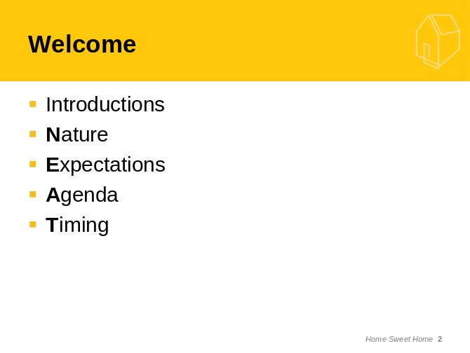

Objectives of the Workshop
Now that you have the participants’ full attention take a moment to briefly review the objectives of the workshop:
- Discuss relocation manager’s roles and responsibilities, Plan My Move, MilitaryINSTALLATIONS, and Military OneSource services
- Discuss the role of the housing office, housing referral services, housing privatization
- Learn how to create a housing budget
- Understand how to research and choose a new neighborhood
- Learn the decision-making process for a rent versus buy benefit analysis
- Understand the rental process and all the laws governing landlord – tenant relationships
- Discuss the option of buying a property including selection of a real estate agent and the mortgage/closing process
Close out the introductory portion with a comparison of the objectives to the expectations and summarize the other points you will discuss as part of this workshop or materials you will collect and forward after the workshop.
SlidE:
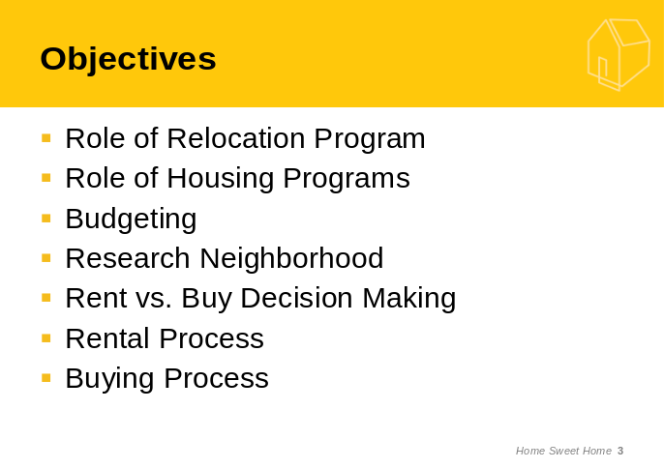

Chapter 1
Relocation Programs and Services

Attention Step: Moving is a complex process and one that requires careful planning. Often in the military we don’t have the luxury of house hunting trips, six months to plan or an assigned personal counselor. The service member manages their own move. The relocation program in the Family Center has the resources to assist the military member and family to plan a cost effective and efficient move.
Slide:
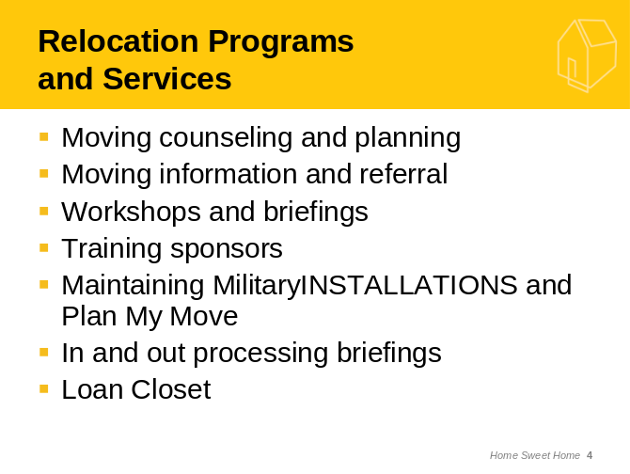
Instructor: Demonstrate the following 3 websites, MilitaryINSTALLATIONS, Plan My Move and Military OneSource websites focusing on the housing related information and resources that each provides.
Slide:
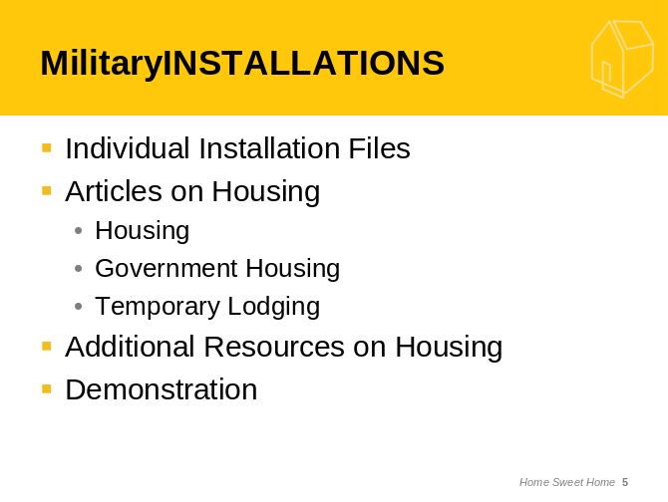
Internet DemonstratE: Tour of MilitaryINSTALLATIONS http://www.militaryinstallations.dod.mil
Note: This requires Internet capability to present a live demonstration or you can prepare PowerPoint slides using your installation as the examples. Make sure to focus on housing related information. The length of the demos will depend on the timing of the Workshop.
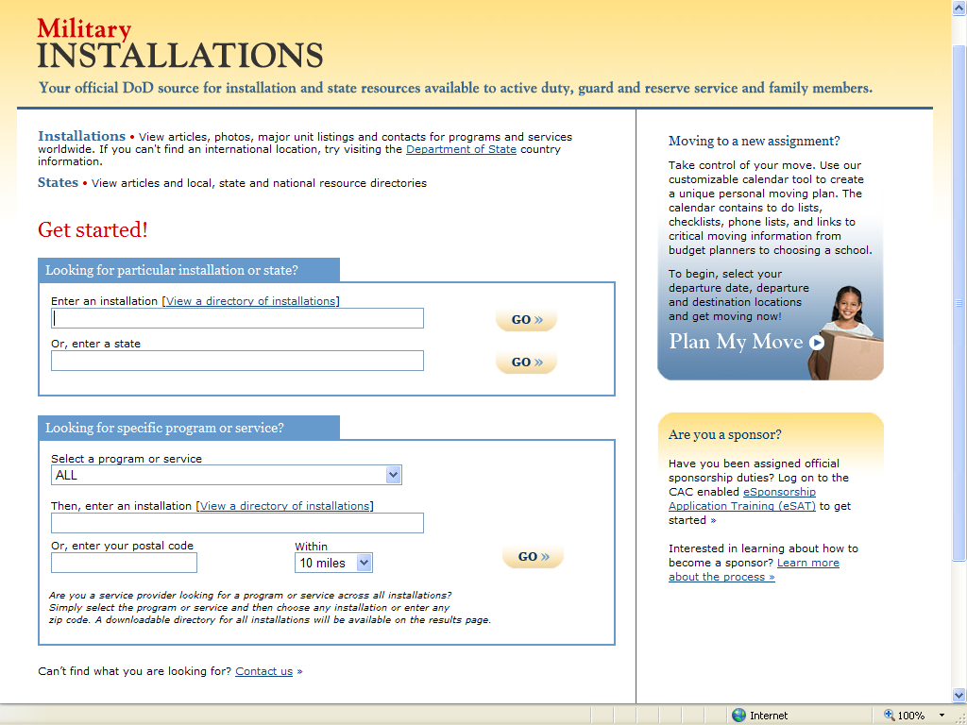
Slide: Discuss and describe the Plan My Move moving calendar.
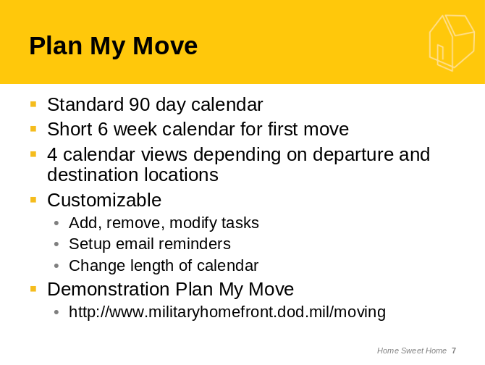

Internet Demonstrate: Tour of Plan My Move http://www.militaryhomefront.dod.mil/moving.
Note: Make sure that you focus on the housing related information in the calendar and point out to the transferees all of the information they can connect to through the calendar. Stress the importance and advantages of creating a custom calendar.
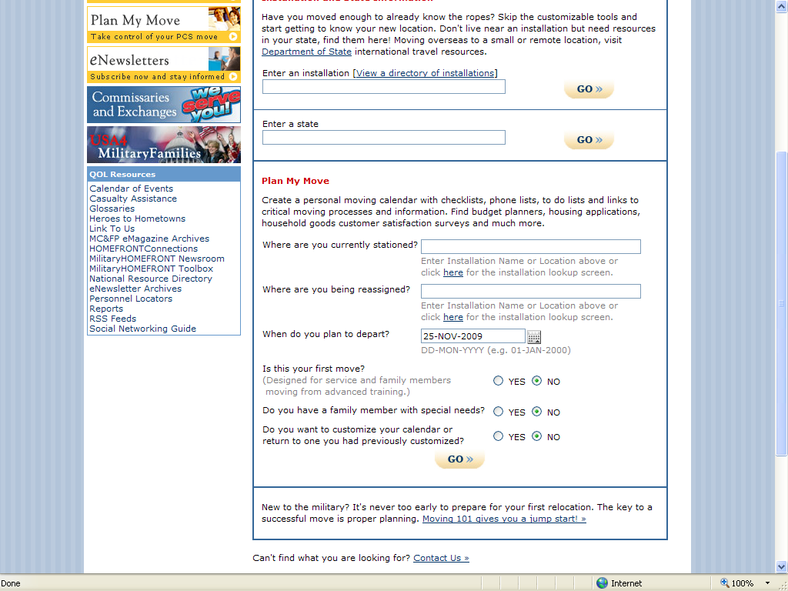
Slide:
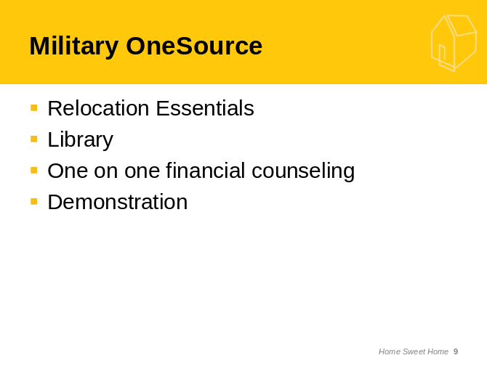

Internet Demonstrate: Tour of Military OneSource http://www.militaryonesource.com.
Note: When you are looking at the resources in Military OneSource make sure to focus on the neighborhood and cost of living calculators contained in their Relocation Essentials application. You may want to visit the library information contained in MOS on moving and housing issues as well.

Optional: It might be a good idea to have downloaded and printed the Brochure that describes the above resources. The Brochure can be downloaded at: http://cs.mhf.dod.mil/content/dav/mhf/QOL-Library/Project%20Documents/MilitaryHOMEFRONT/Service%20Providers/Promotional%20Materials/PMMbroch_27Aug09%5B1%5D.pdf
Transition Step: The Relocation Office coordinates closely with the Housing Office. We will look at the programs and services that Housing Provides next.

Chapter 2
Government Housing Office Programs
and Services
Attention Step: The military has a government housing office that is responsible for assisting in obtaining housing quickly and efficiently. The housing office manages government housing assignments and terminations and referral to local community rental properties. Overseas the housing office also manages the furnishings program. Mostly the rental program has been automated through the Automated Housing Referral Program (AHRN). The housing office has no direct relationship with the public-private housing privatization projects except to distribute information. Each of the Services have housing websites and the housing privatization contractors have their own websites.
Slide:
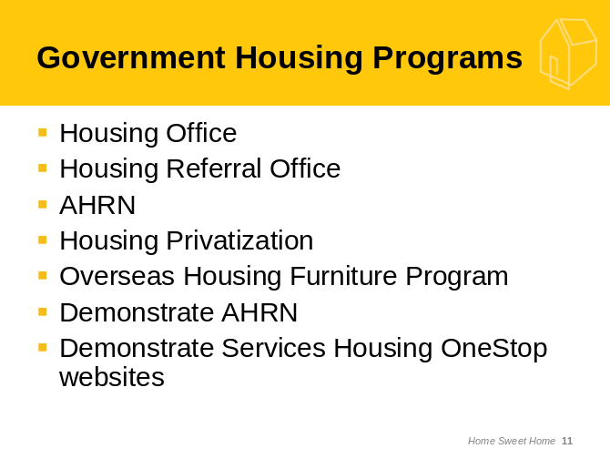
Internet Demonstrate: Tour of AHRN http://www.ahrn.com
Note: AHRN requires a Login, so make sure that the instructor has set their user name and password before doing the Internet demonstration.
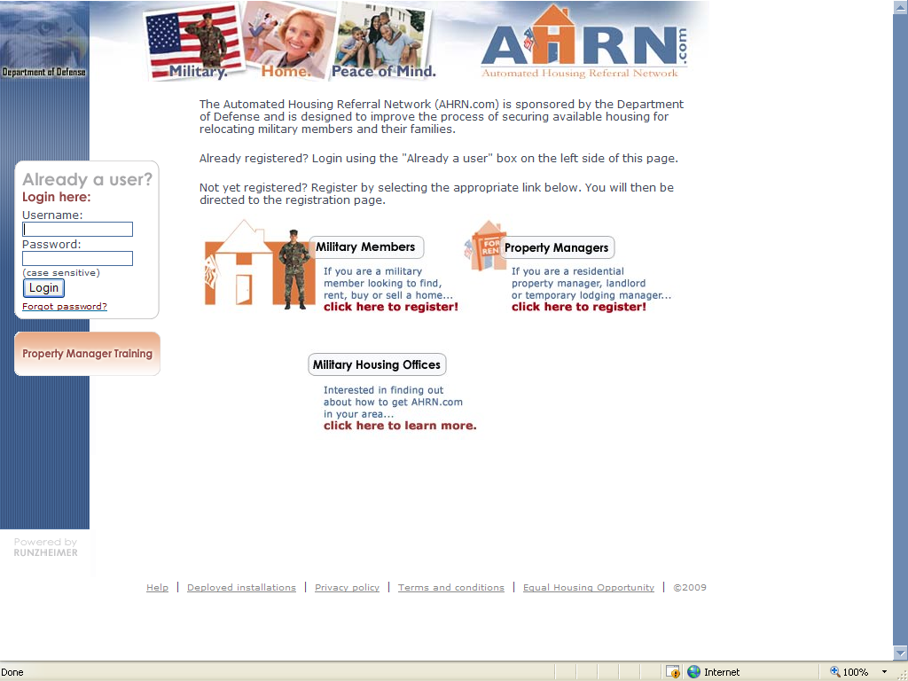

Internet Demonstrate: Optional Tour of Service Housing websites.
Note: When touring these websites or the housing privatization websites make sure that you choose your examples before you begin the demonstration. Depending on your Service, you might want to include an Internet demonstration of the following websites.

Slide: Army Housing Online User Services: https://www.housing.army.mil/ah/
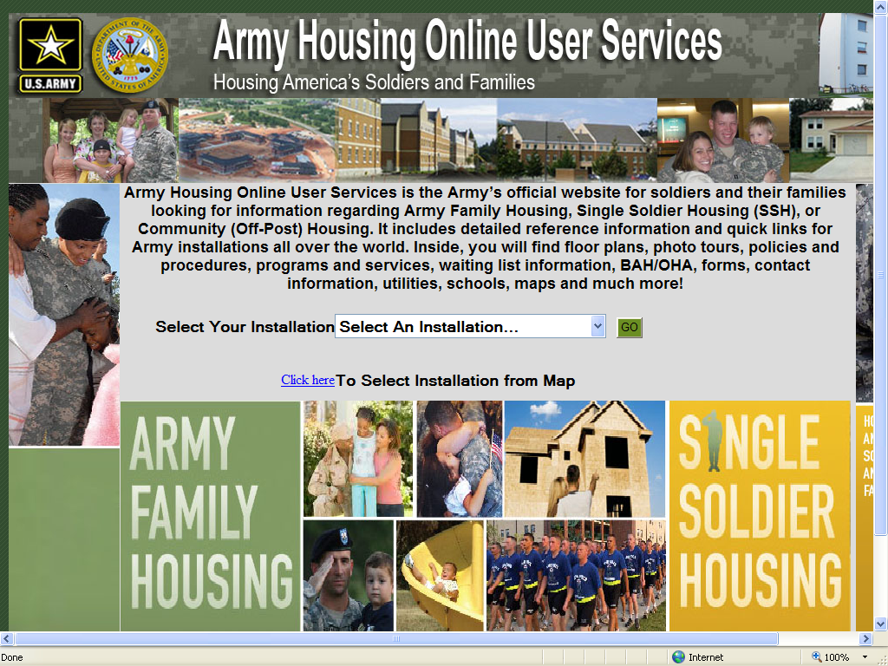

Slide: Navy Onestop http://www.housing.navy.mil/onestop/

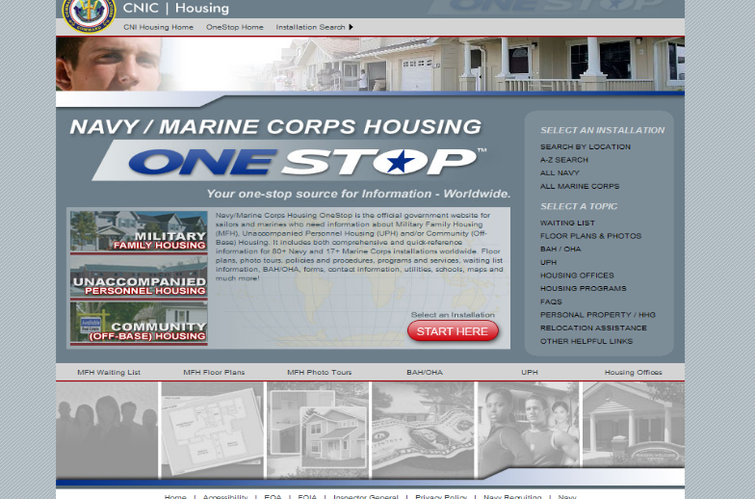

Note: The Air Force has a secure website and if this is an Air Force workshop, the instructor should have the information ready to go before they begin the tour of the website. This means that the instructor must have an approved user name and password or ECA/CAC access.

Transition Step: In many locations, especially complex higher cost major metropolitan areas government housing will not be an option. Living “on the economy” will be the only option for service and family members. Now we will look at budgeting for your housing needs assuming you will be living in the local community near your new location.

Chapter 3
Budgeting for Your Housing Needs
Attention Step: Moving is always costly. DoD reimburses some expenses but not all when you receive PCS orders. DoD allowances can be found at the Per Diem Committee website. Knowing how much you can afford is critical. This leads you to the rent versus buy decisions, than analyzing what you can afford in terms of a mortgage is the next step. Selecting a type of mortgage and understanding your rights and protections before you close on a property will also be discussed.

Slides:
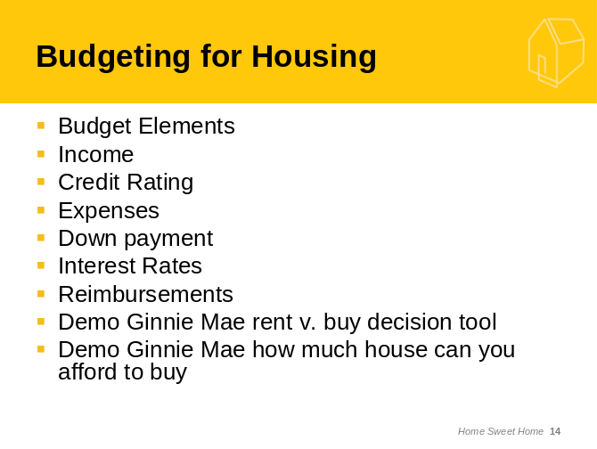
Exercise:
Instructor: Ask the participants to brainstorm the considerations that come into play when determining a budget for rent or mortgage payment. Write the ideas on a white board or chart paper and incorporate them into the following discussion.
Internet Demonstrate: Demonstrate the calculator that will help you determine whether you can rent or think about purchasing. If the answer comes up that you might be able to purchase, then view the next Ginnie Mae website. This is the rent versus buying decision Ginnie Mae website -- http://www.ginniemae.gov/rent_vs_buy/rent_vs_buy_calc.asp?Section=YPTH

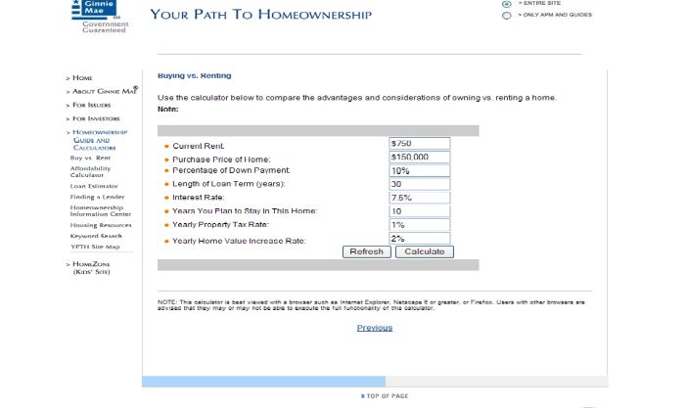

Optional: Second Ginnie Mae website is to determine how much house you can afford. Use this only if you have homebuyers in the audience -- http://www.ginniemae.gov/2_prequal/intro_questions.asp?Section=YPTH

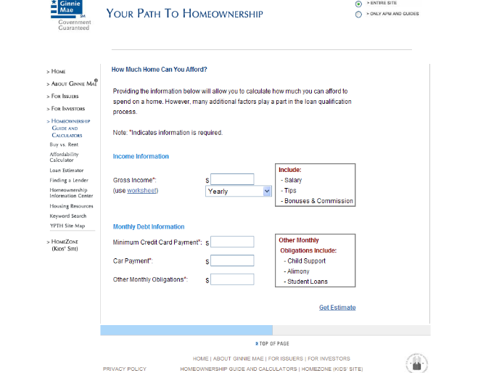
Instructor: Discuss Military OneSource resources on financial counseling. These include:
In-person financial counseling, http://www.militaryonesource.com/MOS/Tools.aspx, is available in most locations through Military OneSource, in partnership with the National Foundation for Credit Counseling (NFCC). NFCC provides financial education and counseling services at hundreds of local offices nationwide. Military OneSource arranges for you to meet face-to-face with a financial consultant in your community.
This program is specially designed to provide short-term, solution-focused financial counseling for service members and families who may be experiencing a financial setback. Whether you need advice for a specific debt problem or basic assistance with money management, a financial expert can help you analyze your situation and develop a debt management plan.
Contact Military OneSource at 1-800-342-9647 to schedule an appointment with a financial consultant. If you want to do some work yourself, Military OneSource has a Financial Calculator page, http://www.militaryonesource.com/MOS/Tools.aspx . These calculators can help you in many aspects of financial decision making. For more financial tools and information, visit SaveAndInvest.org, http://www.saveandinvest.org/. Save and Invest is a financial education program designed to improve the saving and investing knowledge of military service members.

Transition Step: Preparing for the frequent military moves is important and the resources we just discussed are vital so remember to refer to this manual frequently. Let’s look at how you might choose a neighborhood when you are hundreds or even thousands of miles away from your destination.

Chapter 4
Choosing a Neighborhood
Attention Step: It is almost impossible when PCS orders are received to take a well planned and well timed house hunting trip, so military families have to depend on the resources provided through MilitaryHOMEFRONT, Military OneSource and independent Internet research.
Exercise:
Instructor: Take a moment to use the white board or flip chart (time permitting) to ask the participants to share some of their wants/needs in a new neighborhood. Try to tie the participant’s responses into the discussion of what to look for in a new neighborhood. Remind audience that this step applies to both rental properties and home buying.
Worksheet: Participants should be instructed to review housing needs/wants worksheet as instructor goes over key points (Worksheet F).
Exercise:
Discussion: Ask the participants to provide other reasons why it might be helpful or advantageous to live in a neighborhood with other military families.
Slide:
Note: Use the slides to summarize the discussions and the exercises.
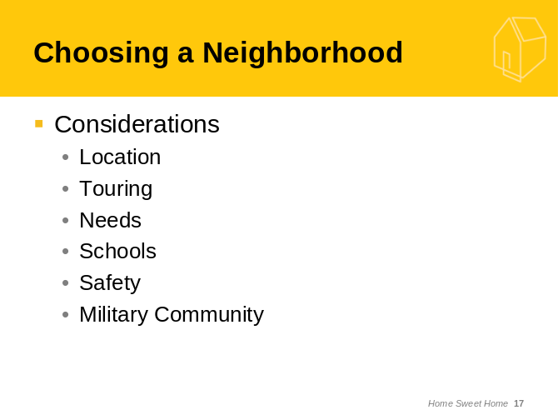
Slide:
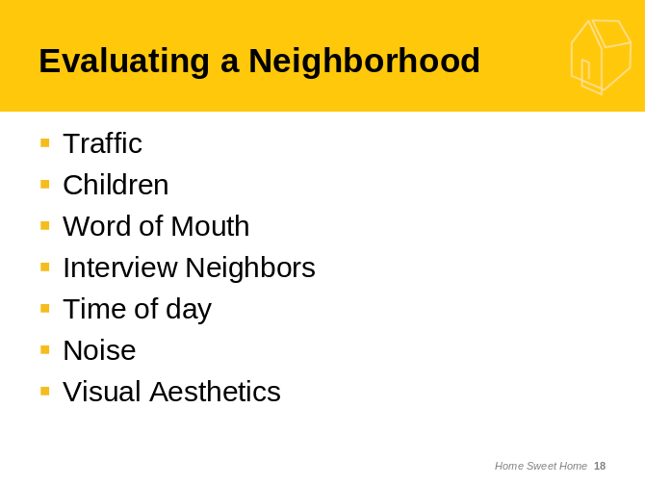

Transition Step: Most military families choose to rent if they cannot live on base. Renting is usually easier as they will generally be receiving orders again soon. Because over 80% of the military population rents, let’s look at how to rent an apartment or house in detail.

Chapter 5
Renting – The Process
Attention Step: The military population has two choices either live on the installation in government housing or leased government housing, or live off the installation. Living off the installation means living in the local community. When you live off the installation your choices in CONUS are to buy or rent. Overseas your choice is to rent. Very rarely does anyone buy in foreign countries, but it is not impossible. Over 80 percent of the military population live in rental properties and that percentage continues to increase in our current economic climate.
Slides:
Note: This section has a series of slides and several worksheets.
Exercise: Worksheet A and Worksheet B should be used to determine requirements for a new apartment and determining an affordable rental range. Make reference back to the exercise Worksheet F Needs vs. Wants.
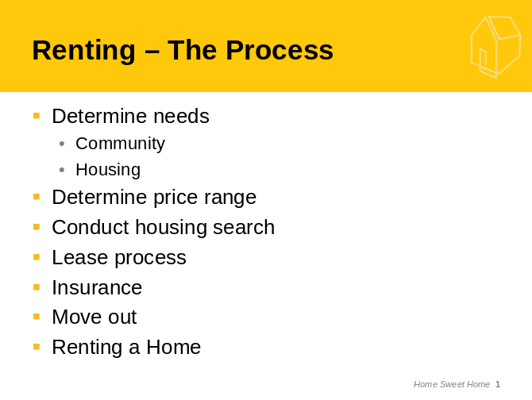
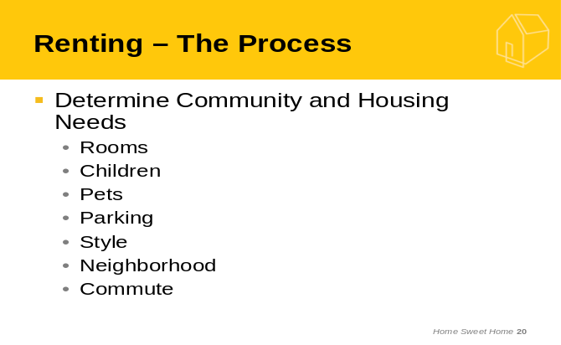

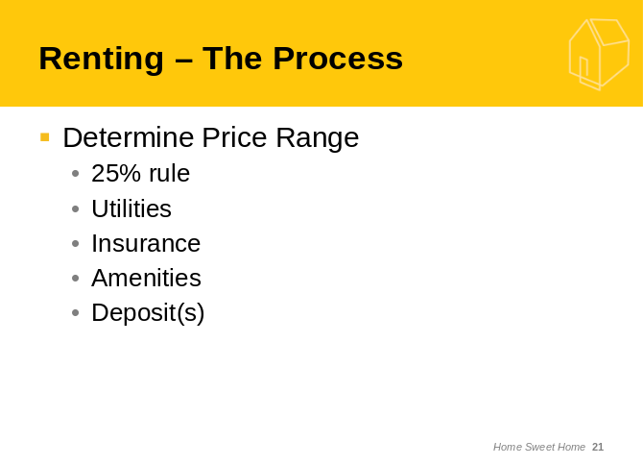
Note: This is where Worksheet C is demonstrated along with the discussion.
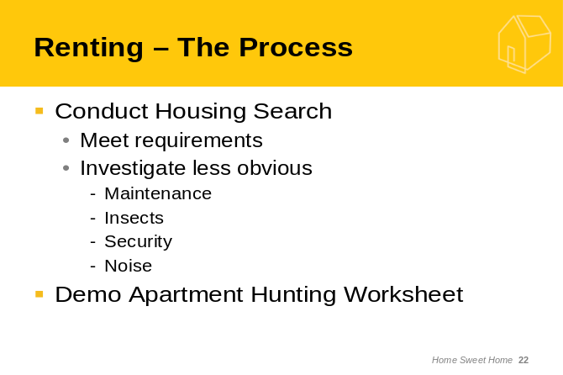
Note: Make sure to reference Worksheet D in this discussion, “The Military Clause” that should be included in any lease.
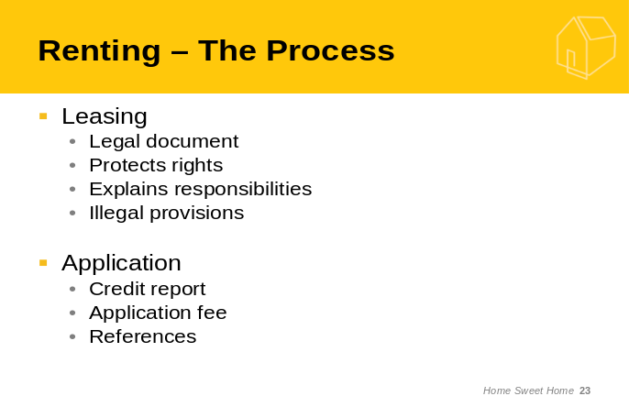

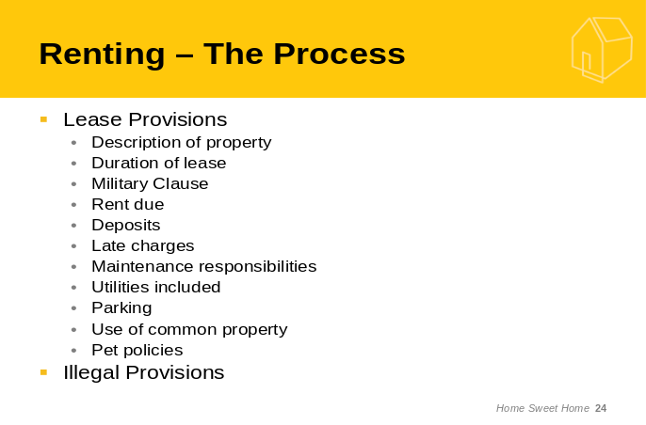
Note: Review Worksheet E Apartment Damage Pre-Move list.
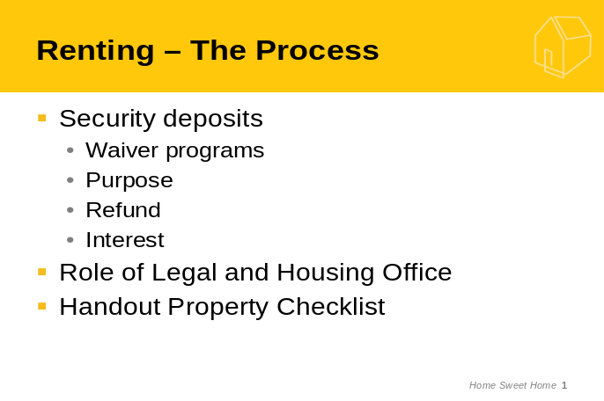

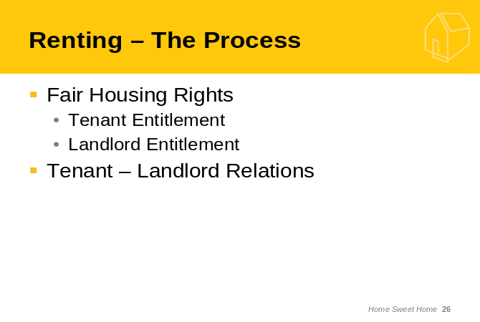

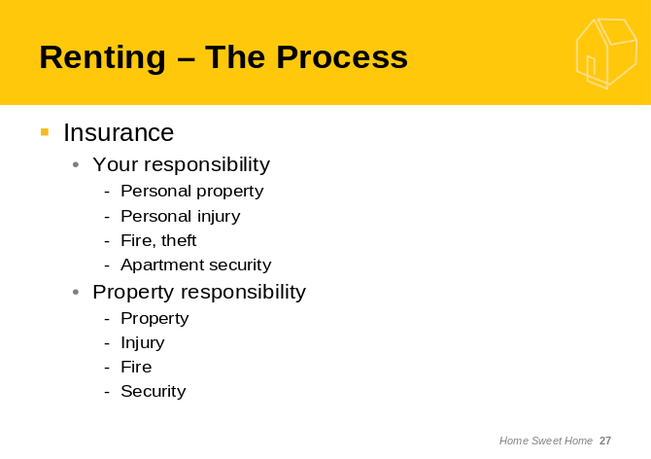

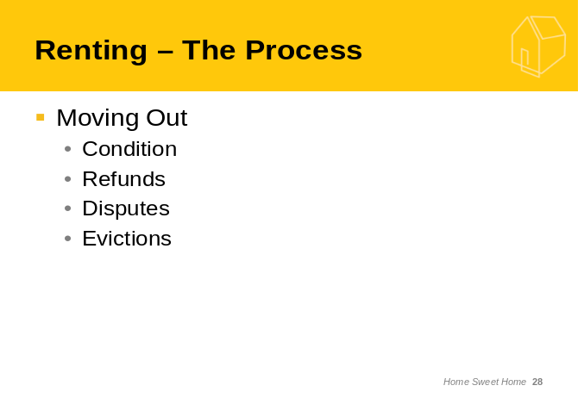
Optional: If time permits discuss the differences between renting an apartment and renting a house.
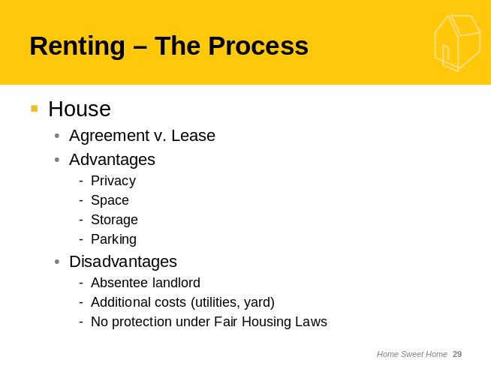
Transition Step: Often if a family knows that they want to retire in a specific area they will buy a home in that location years before retirement. Buying is very complex and we will only do a brief overview next in this workshop.

Chapter 6
Buying – The Process
Attention Step: Purchasing a home is one of the most important decisions you will ever make and the costliest. American’s “wealth” is directly tied to their homes. It is the American dream to be a homeowner. This basic value is more difficult for members of the military for many reasons that we will discuss in this section.
Part 1 Selecting an Agent
Exercise: Time permitting, ask the participants to throw out ideas as to what type of qualifications/characteristics they would be looking for when hiring a real estate agent. Write these up on the white board or chart paper and refer to them as you continue to discuss real estate agent qualifications.

Slides:


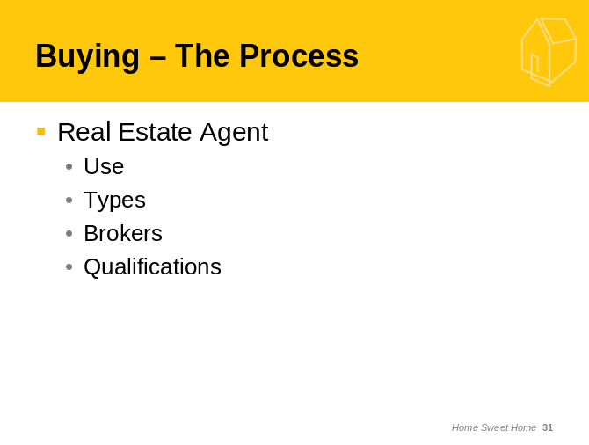

Part 2 Home Buying Process
Slides:
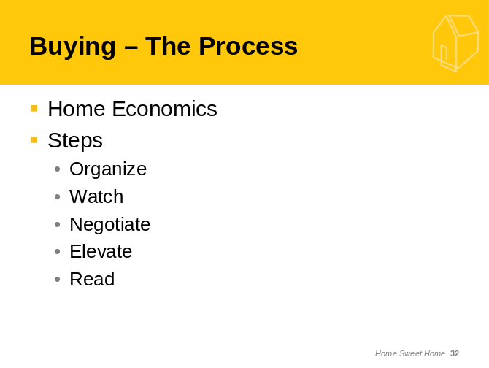

Internet Demonstration: Show the Home Economics HUD Brochure http://www.hud.gov/news/homeeconomics.pdf.

Internet Demonstration: Explore the information that can be found at the Realtor.com website. http://www.realtor.com
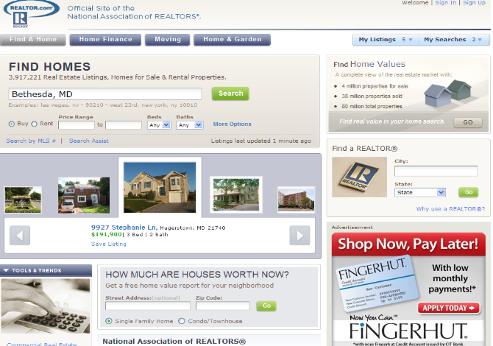
Internet Demonstration: Demonstrate the information that can be found at the Fannie Mae website http://www.fanniemae.com/kb/index?page=home&c=homebuyers


Part 3 Mortgages
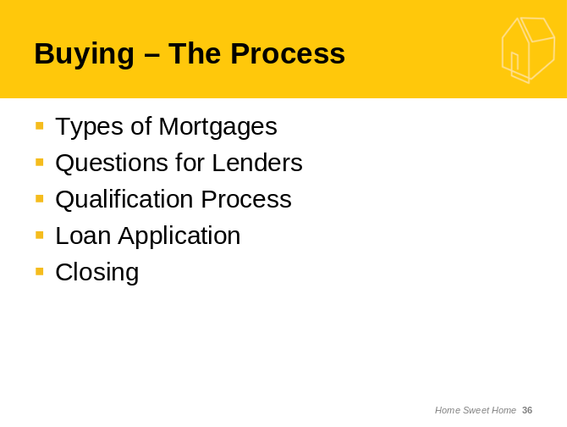
Internet Demonstration: Go to the VA Home Loans http://www.va.gov and select home loans, then review the information available.

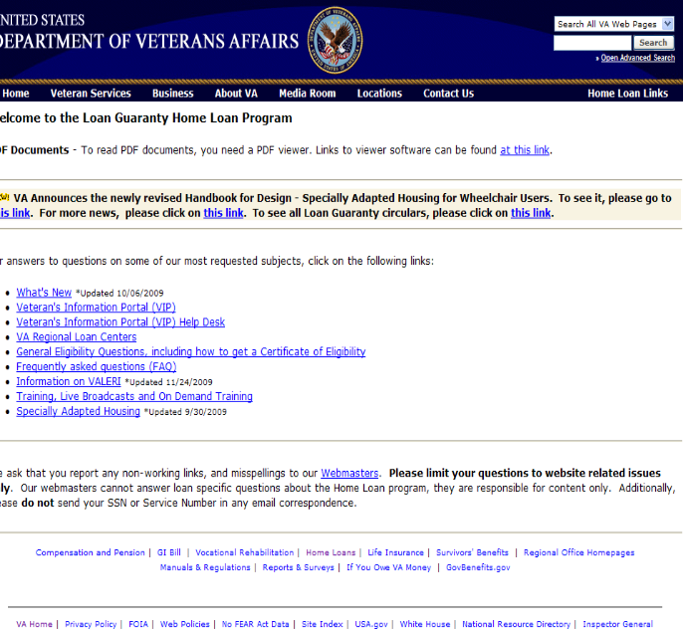

Internet Demonstration: Return to the Fannie Mae http://www.fanniemae.com and review the mortgage information.



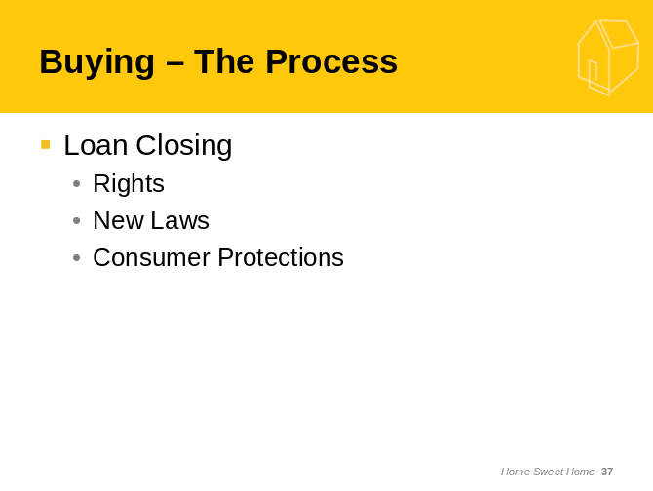

Exercise: Worksheet H shows the new HUD-1, the new Good Faith Estimate and the new comparison between the HUD-1 and Good Faith Estimate. Alternatively, these forms can be reviewed on the Internet at the http://www.hud.gov website, under RESPA.

Transition Step: It looks like we are about to run out of time. We have just scratched the surface of home buying, we leave you with our strong recommendation to seek out professional advice if you are thinking about buying a home and to fully understand all of the current rules on obtaining a mortgage.

Summary/Wrap Up
Attention Step: There has been a lot of information presented today. Let’s first review your Expectations, our Objectives and determine if we have missed anything. Then we have (insert how much time is left) to take questions. Finally, we would like everyone to fill in the Evaluation.
Note: Remember to make a list of any due outs that you promised to the attendees.
Slide:
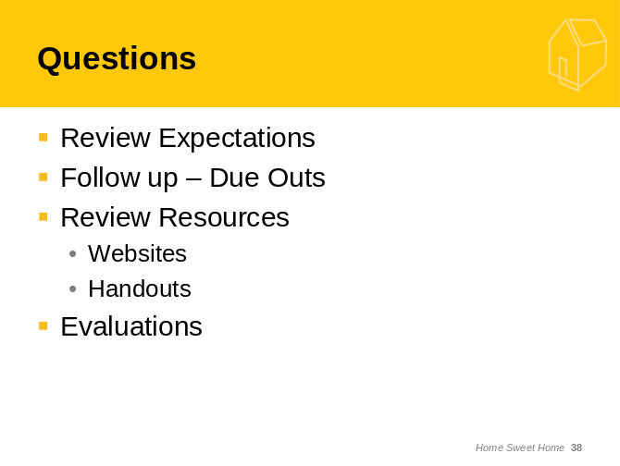

Handout: Evaluation Worksheet I

Worksheets
- Requirements for a New Apartment
- Determining Your Affordable Rental Range
- Apartment Hunting Worksheet
- Military Clause
- Apartment Pre-Move-In Damage List
- Housing: Needs vs. Wants
- Home Buying Worksheet
- HUD -1 and Good Faith Estimate
- Evaluation Form

Worksheet A - Requirements for a New Apartment
Preferred Location:
Urban ____________ Suburban __________ Rural ________________
Desired commuting time: ___________________
Desired transportation: Car/Carpool ________Public Transportation_______
Desired proximity to shopping: _____________________
Desired proximity to place of worship: ___________________
Desired proximity to _______________________________________________(other)
Medical Requirements:

Educational Requirements:
School: ____ Public _____ Private/Parochial
Day Care: Age(s) of Children ___________________ Center ______ or Home_____________
Nursery/Pre-school
Elementary
Middle/Junior High
High
College
Other
Recreational Requirements:

Leisure Requirements (organizations/activities):

Other Requirements:

Rental Housing Requirements: (M = Mandatory/P = Preferred)
- Garden _________ Townhouse ________ Multi-family _________
Single Family _______ Room in private home ____________
- Number of bedrooms:
- Number of bathrooms:
- Number of rooms:
- Children:
- Pets:
- Parking:
- Storage/Closets:
- Air Conditioning:
- Laundry:
- Swimming pool:
- Rent:
- Other requirements (i.e. Jogging, Cable TV, Distance between parking spot and
your unit):
- Worksheet B - Rental Calculation Worksheet

Use this worksheet to determine your maximum monthly rental payments.

Employee Annual Gross Income $__________________+
Spouse Annual Gross Income $__________________+
Other (verifiable) $__________________
Equals
Total Annual Income $__________________divided by 12 equals
Monthly Gross Income $__________________times 25 percent equals
Maximum Rent $__________________

Worksheet C - Apartment Hunting Worksheet
Rental Contact:
Phone Number:
Address:
Monthly Rent:
Lease Term:
Utilities Provided:
Parking Area:
Apartment Number:
Floor:
View:
Exposure:
Special Services:
Neighborhood:

Proximity to Transportation/Shopping:

School District/Proximity to local schools:

Building Age/Condition/Windows:

Air Conditioning:
Heating:
Noise:
Pets Permitted:
Furnishings/Window Coverings:
Living Room Size/Daylight/Fireplace:

Dining Area Size:

Entry Hall Size/Closets:

Kitchen Size/Workspace/Appliances/Storage:

Master Bedroom Size/Closets:

Additional Bedroom Size/Closets:

Additional Bedroom Size/Closets:

Master Bathroom Size/Tub/Shower:

Additional Bathroom Size/Tub/Shower:

Other Rooms (Type, description):

Terrace/Garden/Storage Area:

Miscellaneous items:

Overall Impression:

Tenants’ Comments:

Worksheet D - Military Clause

Worksheet E - Apartment Pre-Move-In Damage List
 | Excellent  Condition | Good  Condition | Fair  Condition | Poor Condition/  Not Working
Bedrooms
Living/family room
Dining area
Kitchen
Air conditioning
Fireplace
furnace type
# of outlets
Bedroom privacy
Blinds/curtains
Cable TV connection
# phone jacks
High speed Internet
Carpet
Hardwood floors
Closet space
Storage
Furniture
Light Fixtures
Natural Light
Pain/wall condition
Patio/balcony
Pets allowed
Upstairs/downstairs
View
Water pressure
Age of appliances
Counter space/ drawers
Dishwasher
Garbage disposal
Gas/electric
Microwave

Worksheet F - Housing: Needs vs. Wants
Use this worksheet to list your “needs” for a house and neighborhood. You can also list your “wants” (i.e. fireplace, wood floors, community pool, etc.)
Housing Needs Housing Wants

Neighborhood Needs Neighborhood Wants

Worksheet G - Home Buying Worksheet
Make multiple copies of this form and take it with you to each property you visit on your house hunting trips. Your realtor may provide you with the Multiple Listing Service (MLS) printout for each home he/she shows you but this worksheet will help you recall and compare each house you visit. Attach a copy of this worksheet to each listing.
Date:
General Information:
Address:

Community:
Listed Price: ________________________ Taxes: ____________________
HOA Dues_________________________
Additional Fees/Abatements:
Estimated Utility Costs:
Lot Size:
Year Built: __________ Square Feet: __________
Floor Plan:
Garage (1 car, 2 car, 3 car):
Rooms:
Total Number:
Size of Master Bedroom:
Size of Bedroom #2:
Size of Bedroom #3:
Size of Bedroom #4:
Size of Master Bathroom:
Size of Bathroom #2:
Size of Bathroom #3:
Size of Master Closet:
Size of Closet #2:
Size of Closet #3:
Size of Closet #4:
Size of Kitchen:
Size of Family Room:
Size of Living Room:
Size of Dining Room:
Other Rooms:
Interior:
Appliances:
Closets:
Attic:
Basement:
Ceiling Fans:
Heating/Air Conditioning (type):
Security System:
Utility Room(s):
Exterior:
Yard:
Deck/Porch/Patio:
Foundation/drainage:
Doors:
Landscaping/Trees:
Driveway:
Roof:
Gutters:
Siding Material:
Sprinkler system:
Windows:
Swimming Pool/Hot Tub:
School Districts:
Elementary:
Middle School/Junior High School:
High School:
Neighborhood:
Condition of Neighborhood:
Traffic/Noise:
Power Lines:
County/City Services:
Trash Removal (public/private):
Public Transportation:
Airports:
Police/Fire:
Near Landfill/Dump/Factory/Production Plant:
Proximity to Shopping, Recreation, Schools and Work:

Worksheet H - Good Faith Estimate and HUD – 1

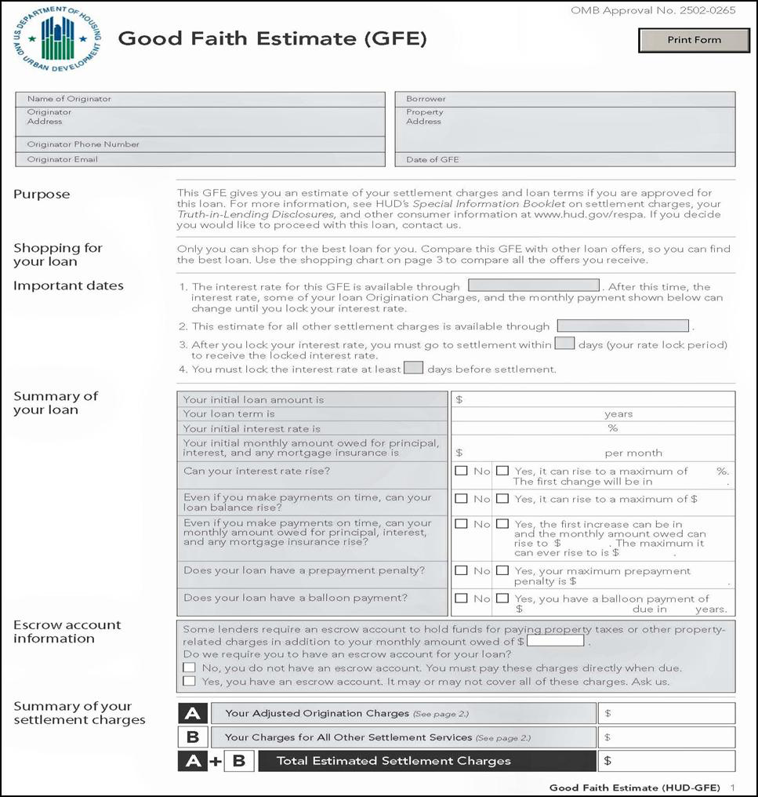

Good Faith Estimate Page 2
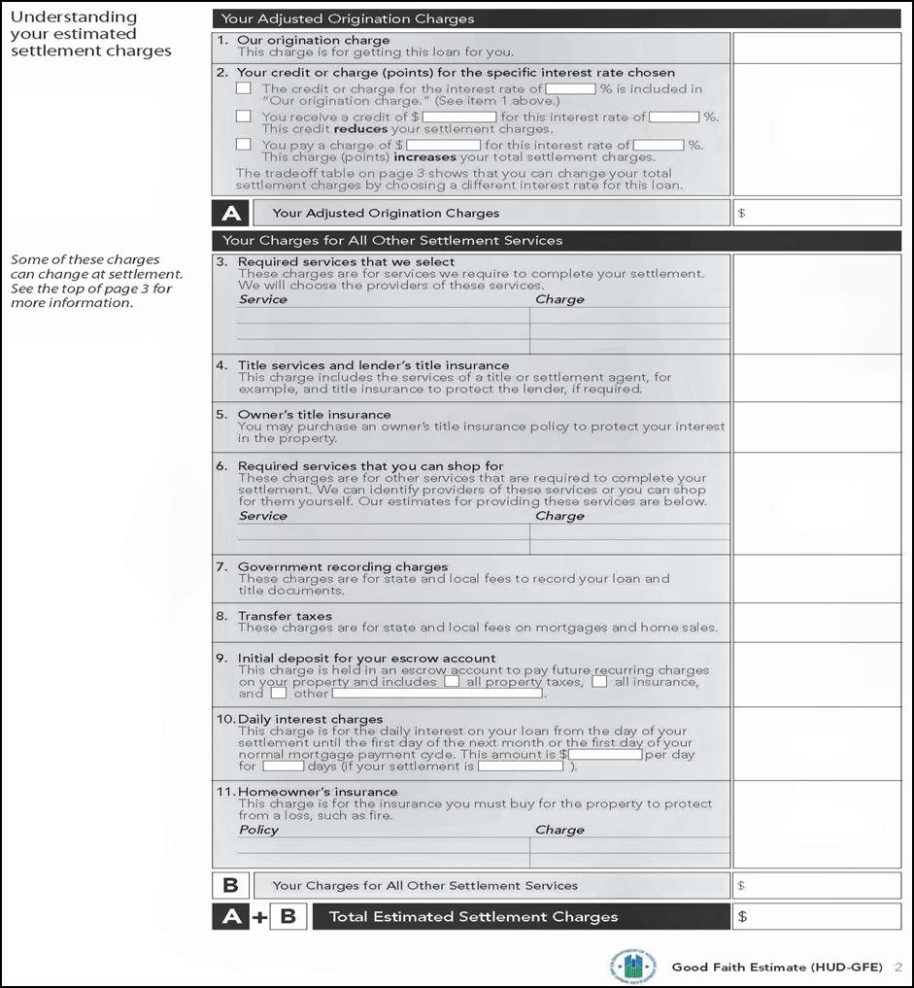

Good Faith Estimate Instructions
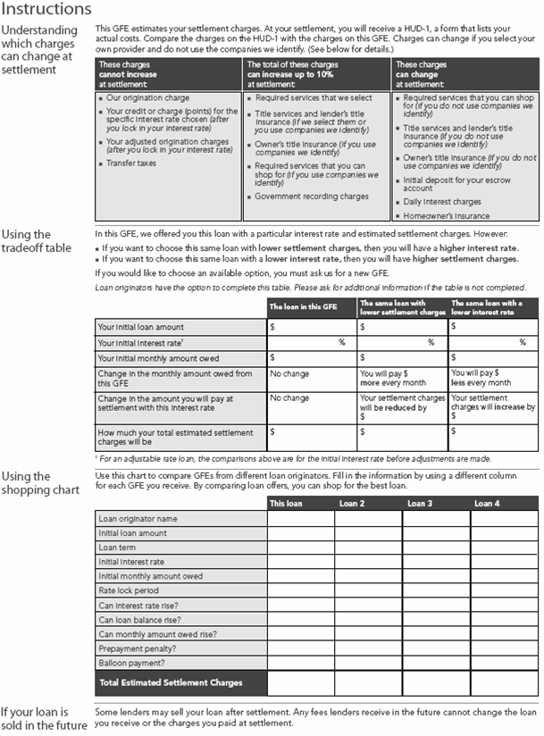

HUD 1
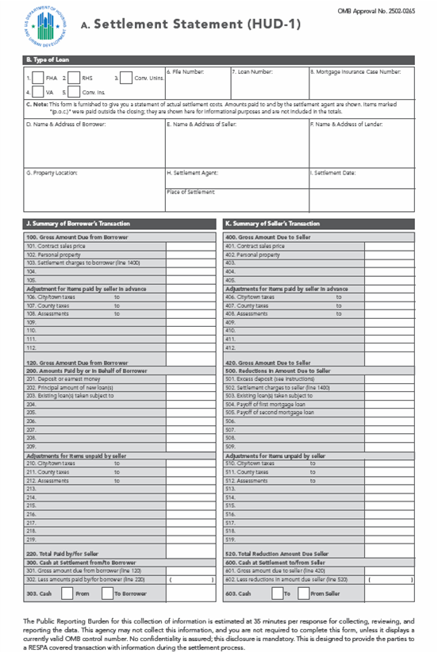
- Revised to compare with GFE.
- Categorized - eliminate free proliferation.
- Third party charges listed outside column.
- Added page to HUD-1/1A.
- Highlights key loan terms.

HUD 1 Page 2
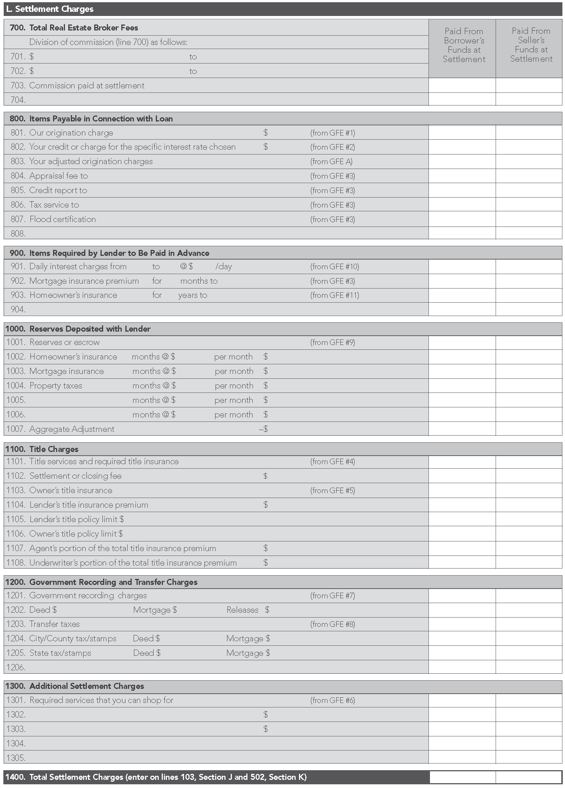
HUD - 1 Page 3
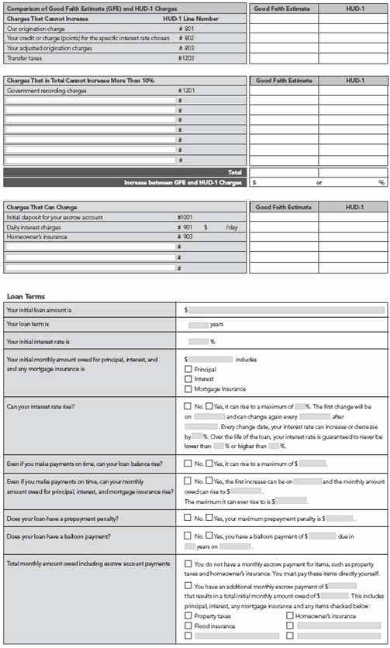

HUD 1 and GFE Comparison Chart
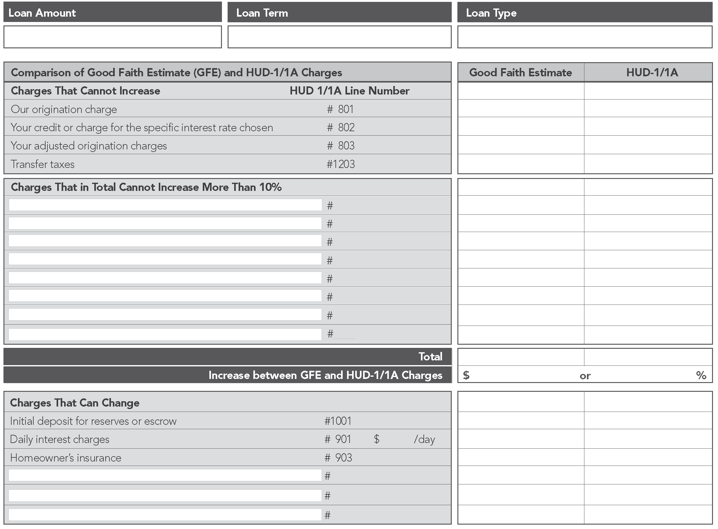
- Compares charges listed on GFE & actual charges listed on the HUD-1/1A.
- Identifies tolerance compliance or violation.
- Three Categories:
  - Charges that cannot increase
  - Sum of charges that cannot increase more than 10%
  - Charges that can increase

Comparison Chart, Continued

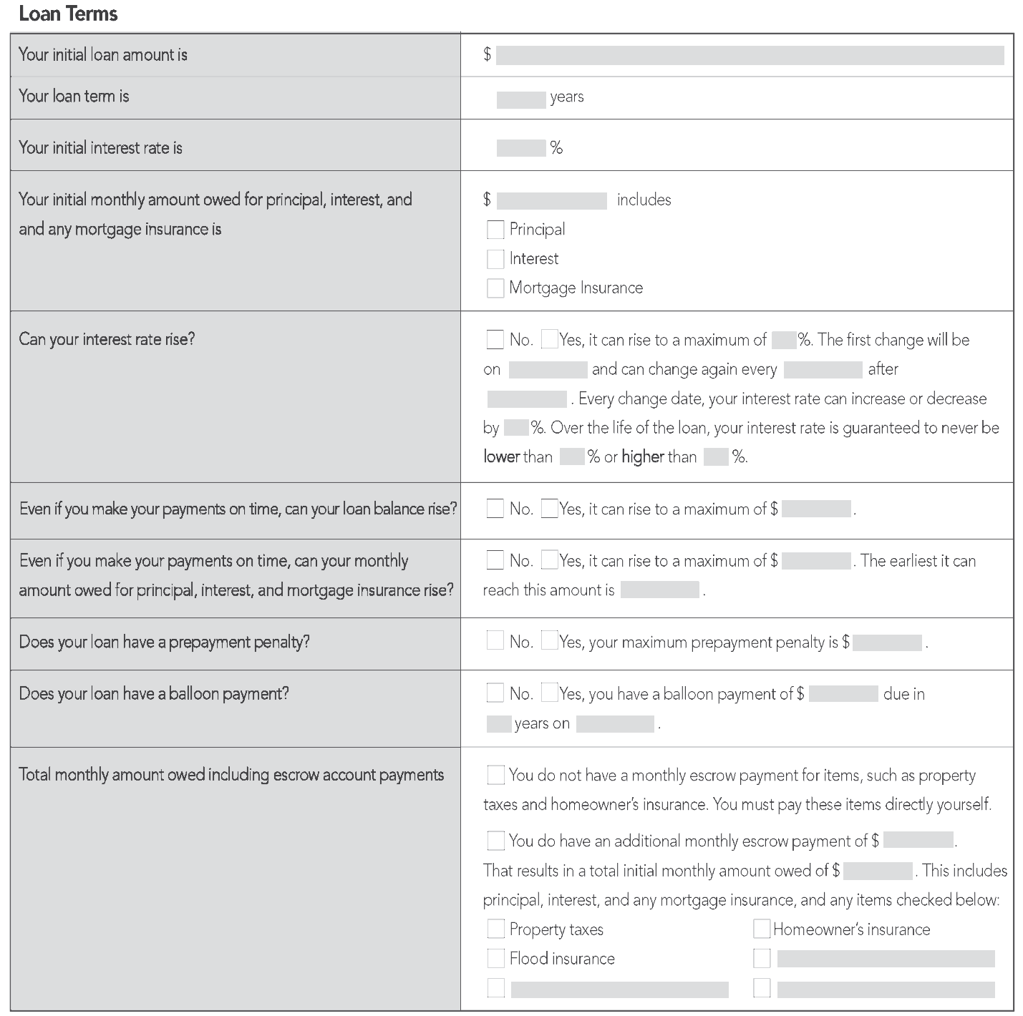
- Ensures borrowers that they received loan they applied for.
- Highlights key loan terms.

Worksheet I - Evaluation
- Was this workshop helpful?

- What information did you find most helpful?

- What information did you find least helpful?

- What additional information would you like to have incorporated in future workshops?

- Is the workbook helpful? If not, what would make the workbook more helpful?

- Additional comments

References

Websites:
Army Housing Online User Services: https://www.housing.army.mil/ah/
Automated Housing Referral Network: http://www.ahrn.com
Buying vs. Renting Calculator: http://www.ginniemae.gov/rent_vs_buy/rent_vs_buy_calc.asp?Section=YPTH
Department of Defense Education Activity: http://www.dodea.edu/home/
Department of Defense Homeowners’ Assistance Program: http://hap.usace.army.mil/
Energy Efficient Mortgage: http://www.fha.com/energy_efficient.cfm
Fannie Mae: http://www.fanniemae.com/index.html
Fannie Mae – Home buying tool: http://www.fanniemae.com/kb/index?page=home&c=homebuyers_homebuyingprocess
FHA: http://www.fha.com/
FHA Loan: Adjustable Rate: http://www.fha.com/adjustable_rate.cfm
FHA Loan: Fixed Rate: http://www.fha.com/fixed_rate.cfm
FHA Loans for Condominium Units: http://www.fha.com/condominium.cfm
Graduated Payment Mortgage: http://www.fha.com/graduated_payment.cfm
Growing Equity Mortgages: http://www.fha.com/growing_equity.cfm
HARP – Fannie Mae: http://www.makinghomeaffordable.gov/refinance_eligibility.html
HARP – Freddie Mac: http://www.freddiemac.com/corporate/buying_and_owning.html
Home Economics by HUD: http://www.hud.gov/news/homeeconomics.pdf
Homeowners’ Assistance Program – PCS Benefits: http://hap.usace.army.mil/EP_PCS.html
Hope for Homeowners: http://www.makinghomeaffordable.gov/
HOPE NOW: http://www.hopenow.com/
How Much Home Can You Afford?: http://www.ginniemae.gov/2_prequal/intro_questions.asp?Section=YPTH
HUD – 1: http://www.hud.gov/offices/hsg/ramh/res/hud1.pdf
HUD – RESPA: http://www.hud.gov/offices/hsg/ramh/res/respa_hm.cfm
Making Home Affordable: http://makinghomeaffordable.gov/modification_eligibility.html
MilitaryINSTALLATIONS: http://www.militaryinstallations.dod.mil
Military OneSource: http://www.militaryonesource.com
Military OneSource Library: http://www.militaryonesource.com/MOS/FindInformation/Category.aspx?CategoryID=141
National Association of Realtors: http://www.realtor.org
National Center for Education Statistics: http://nces.ed.gov/
Navy and Marine Corps Housing OneStop: http://www.housing.navy.mil/onestop/
Plan My Move: http://planmymove.mhf.dod.mil
Realtor.com: http://www.realtor.com
U.S. Department of Housing and Urban Development (HUD): http://www.hud.gov
Veterans Administration: http://www.va.gov
Veterans Administration – County Loan Limits: http://www.benefits.va.gov/homeloans/docs/2010_county_loan_limits.pdf
VA Loan Guarantee Home Loan Program: http://www.homeloans.va.gov/
VA Regional Loan Centers: http://www.homeloans.va.gov/rlcweb.htm



Created for you by the Department of Defense

Relocation Program
Providing policy, tools, and resources to further enhance the quality of life of service members and their families.

