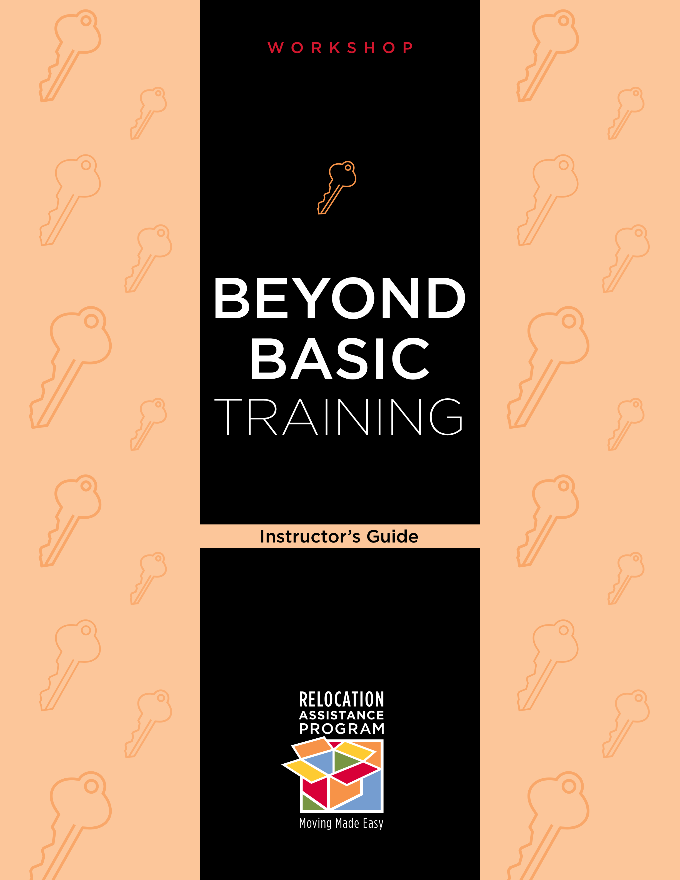
Updated September, 2010

Table of Contents

Table of Contents 2
Workshop Set Up and Overview 3
Audience 3
Timing 3
Workshop Topics 3
Materials 3
Presenter 4
Tips on Using this Guide 4
Begin Workshop 5
Welcome 5
Objectives of the Workshop 7
Chapter 1 Human Motivation 8
chapter 2 Self Esteem 11
chapter 3 Values 13
chapter 4 Goal Setting 14
chapter 5 Decision Making 15
chapter 6 Communication Techniques 19
Summary/Wrap Up 20
Worksheets 21
Worksheet A – Self Esteem 22
Worksheet B – Values 24
Worksheet C – Goal Setting 28
Worksheet D – Decision Making Tools 31
Worksheet E – Effective Communication 34
Worksheet F – Evaluation 38
Reference List 39

Workshop Set Up and Overview
This workshop contains three parts: An Instructor’s Guide, A Student Manual and Worksheets, and PowerPoint Slides supporting the workshop. This workshop is designed to provide participants with the tools and knowledge necessary to plan and make decisions surrounding a Permanent Change of Station (PCS) move. It is designed to walk participants through many important issues related to understanding how we are motivated, the impact of values on our behavior, how to make decisions and effectively communicate our needs during our move.

Audience
The audience for this workshop includes service and family members with PCS orders and those expecting orders in the near future. This workshop can also be used as a generic Life Skills workshop for younger service men and women. Suggested size for the workshop is 20 participants.

Timing
Please note that this workshop can be expanded or condensed depending on available time. The amount of information you or the Instructor feels comfortable presenting will determine the amount of time needed for the workshop. This workshop is heavily populated with exercises and is discussion oriented, be careful to watch the clock. Suggested timing is 2 hours.

Workshop Topics
- Human Motivation
- Self Esteem
- Values
- Goal Setting
- Decision Making
- Communication Techniques

Materials
- Tables and chairs
- Name Tags for all participants and facilitator/instructor
- Sign-in Sheet
- PowerPoint capable computer/projector with screen
- PowerPoint Slide presentation
- Internet compatible computer with connectivity
- White Board with markers or chart paper with markers
- Handouts/Worksheets
  - Worksheet A – Self Esteem
  - Worksheet B - Values
  - Worksheet C – Goal Setting
  - Worksheet D – Decision Making Tools
  - Worksheet E – Effective Communication
  - Worksheet F – Evaluation
- Reference List including publications referenced and websites

Presenter
This workshop lends itself best to a presenter who possesses some expertise and certain capabilities. The presenter should be:
- Familiar with the military and Permanent Change of Stations moves, and
- An expert in Life Skills education

Tips on Using this Guide
The Instructor’s Guide is designed with an Attention Step to introduce each chapter which is an overview and introduction to the chapter. At the end of each chapter there is a Transition Step to the next chapter.
There are notes placed throughout with instructions for the presenter. These are tips to help facilitate the workshop and several suggested exercises that correspond to the worksheets. The Instructor’s Guide contains the attachments from the Student Manual. In this Kit, the Reference list has suggested readings and recommended websites.
The Internet Demonstrations are optional depending on connectivity in the room and time. It is recommended that if there is no connectivity that the workshop slides be augmented with additional screenshots. If there is connectivity, remember to have the websites open to the pages that will be used during the presentation.
The content is all contained in the Student Manual. The presenter must read and be thoroughly familiar with the content in order to present this workshop.

Begin Workshop
Host: Introduce the instructor, if there is one presenting this workshop, or begin the workshop with the welcome.

Welcome
Instructor: Welcome the participants and provide them with some details about your background. Tell the participants your name, title and your experience relocating with the military and your expertise in Life Skills education. If the group is not too large, ask the participants to introduce themselves by stating their names, backgrounds and whether or not they are planning to PCS in the next few months. You can also ask, by a show of hands, how many have a family budget and update it religiously or how many are interested in learning how to budget for a move.
Write the word NEAT on the white board or chart paper and explain the meaning:
N (nature): of the workshop is interactive and participants are encouraged to voice their ideas, concerns, questions and experiences.
E (expectations): of the participants are brainstormed and listed on the white board or chart paper. These should be kept visible and readdressed during the summary at the conclusion of the workshop. This discussion gives the instructor insight into which areas to focus the workshop discussion and the experience level of the participants with the subject matter.
A (agenda): for the workshop is presented according to the objectives listed in the PowerPoint presentation, but may be modified to fit time and expectations.
T (timing): is presented by the instructor.
- Write out on the white board or chart paper approximately when the breaks will occur
- Provide the location of the restrooms
- Offer coffee/snacks if provided
- Remind participants to sign in
- Briefly review the participant’s Student Manual, worksheets, checklists and reference attachments to make sure each participant has the proper materials. This workshop contains:
- Human Motivation
- Self Esteem
- Values
- Goal Setting
- Decision Making
- Communication Techniques
- Reference List including publications referenced and websites
Note: Make available and explain any additional resources that the instructor has brought with him/her and that are available for the participants to view during breaks or at the conclusion of the workshop.
Note: Keep to the times announced, this makes participants more comfortable and encourages participation.
Slide: This slide should be the one in place as the instructor does the Welcome.
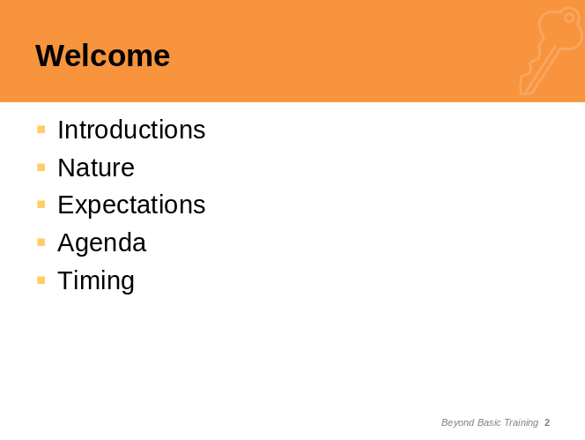

Objectives of the Workshop
Now that you have the participants’ full attention take a moment to briefly review the objectives of the workshop:
Understand and practice the skills necessary for independent living and moving in military:
- Human motivation
- Self esteem
- Values and beliefs
- Goal setting
- Decision making
- Effective communication
Add these objectives to the expectations that were brainstormed with the group. Close out the introductory portion with a comparison of the objectives to the expectations and summarize the other points you will discuss as part of this workshop or materials you will collect and forward after the workshop.
SlidE:
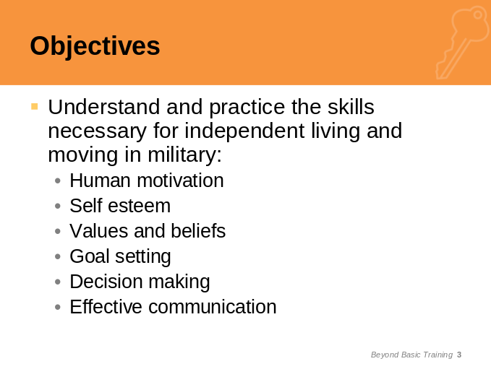

Chapter 1
Human Motivation
Attention Step: Moving is a complex process and one that requires careful planning. How we plan is directly related to what motivates us, our basic value system, how well we make decisions, how well we communicate, the level of our self esteem and how we set and achieve our goals both short and long term. The Relocation Assistance Program in the Family Center has the resources to assist the military member and family to plan a cost effective and efficient move.
Instructor: Begin with brainstorming a list of things that motivate human beings. After you have a good list charted, explain how Maslow’s Hierarchy of human motivation put the first and most widely used framework around these motivations. This theory is still the predominate theory behind human motivation.
Slides:
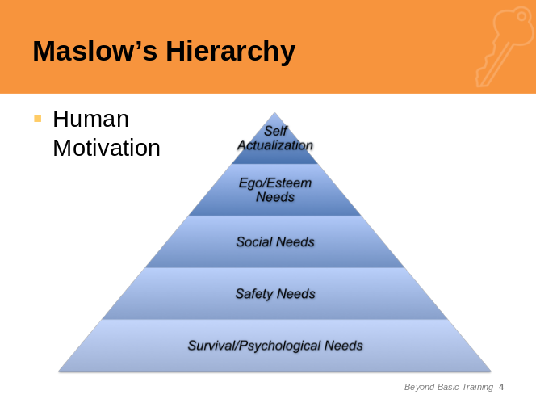
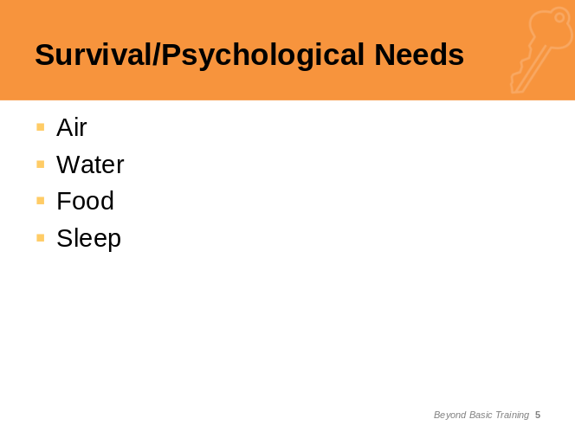
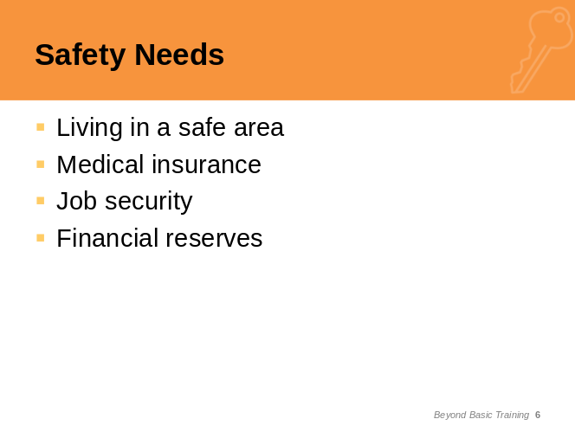
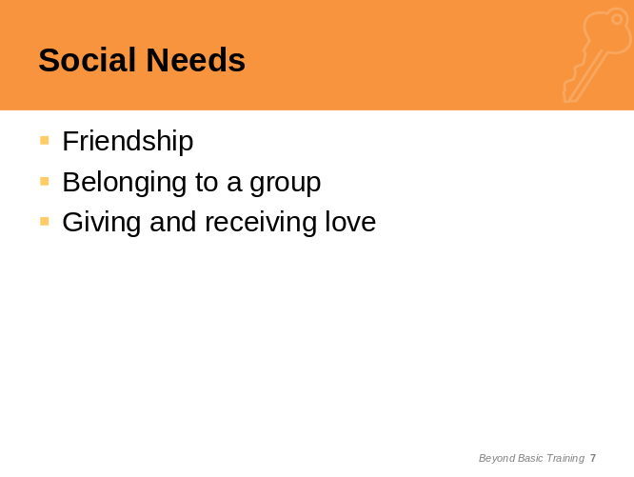
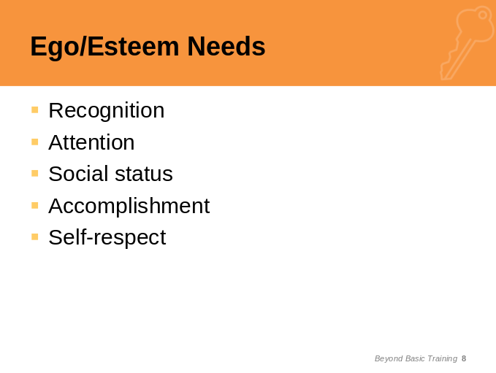
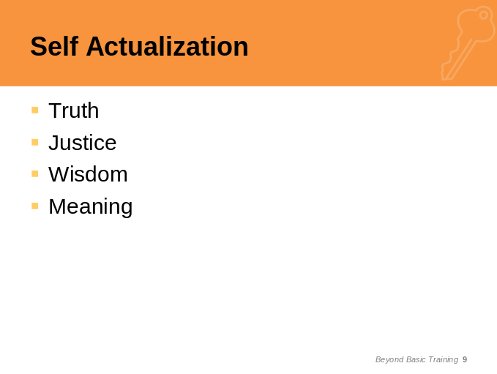

Transition Step: Understanding our personal attributes helps us understand our reaction and ability to adapt when we couple these with Maslow’s theory of human motivation. Nothing in this workshop stands alone, every chapter relates to the other in our ability to understand how we will adapt to the Military culture in general and moving in particular.

chapter 2
Self Esteem
Attention Step: You might ask, why do we need to discuss self esteem and why is it relevant to making wise, timely, efficient decisions when moving? The answer is quite simple: Understanding what self esteem is and if you have high, low, or middle of the road self esteem is a good indication of how you will function during times of stress and in new environments. It is just as important as understanding what motivates you on the most basic levels as we explored with Maslow.
SlideS:
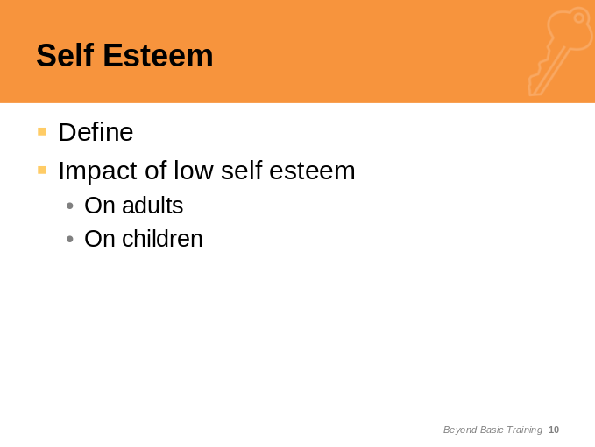
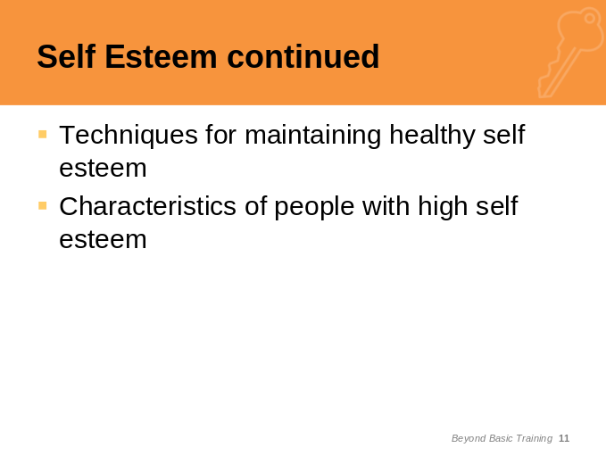
Instructor: Have the participants do Worksheet A, Self Esteem, and then discuss as a group. Remember that time could be a factor as each of these chapters are very interesting and the discussions could get out of hand.
Transition Step: Moving from understanding how you view yourself through our self esteem discussions, let’s take a look at “Values and What is Important to You”. Understanding your value systems will further help define how you will react to moving especially how you will react to new cultures.

chapter 3
Values

Attention Step: If needs are basic wants, and interests are particular preferences, then values indicate commitment to patterns of choice. Values are deeply held convictions which guide behaviors and decisions.

Instructor: Using Worksheet B, Values, have the participants do each section and then discuss each section as you go along relating it to the content in the Student Manual.
Slide:
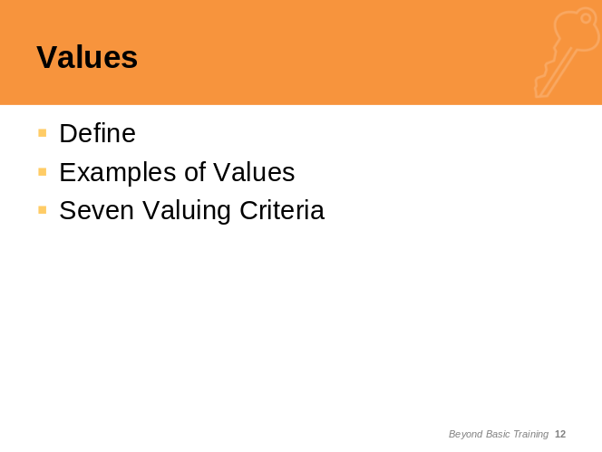

Transition Step: Our value systems govern the way we behave, communicate and interact with others. This is especially critical when we are in the process of moving and settling into new communities and new units. Our beliefs and values determine our attitudes and opinions which we will readily share in our new locations. Understanding that new friends and colleagues will be processing all of the things we have to say from the perspective of their value systems will help us when interacting and adapting to new situations.

chapter 4
Goal Setting
Attention Step: Setting goals, whether they are short term for a day or a specific project, or long term towards earning a diploma, or establishing a career, can sometimes be an elusive skill. Our goals provide the framework upon which decisions are made. It is more important to set goals when moving because more things can go wrong and, without well defined targets, our reaction problems can be exacerbated.

Instructor: Using Worksheet C, Goal Setting, have the participants work in pairs to discuss and set some goals. Ask the group who would like to share and make sure to reinforce the content from the Student Manual on setting goals.

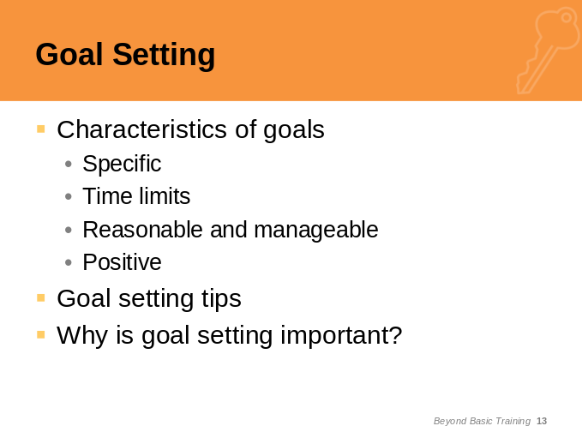

Transition Step: Goals need to be well defined and realistic and have the ability to motivate you and build your self-confidence. First, you need the Decision Making skills before you are able to set goals and establish a plan.

chapter 5
Decision Making
Attention Step: Tools needed for good decision making include increased self-awareness as we discussed in Chapters 1 and 2 today, understanding personal and family values, which we have also discussed and goal setting. Now, let’s move on to techniques you will need to make good decisions. Decision making is a complex process as there are so many different types of decisions. Moving requires numerous decisions from the moment that you get orders.

Instructor: Using Worksheet D, Decision Making Tools, have the participants work through this guide. You will need to present a dilemma for the participants to use as the situation for the exercise. You can give each group a different scenario or you can use the same scenario for the whole group. Here is a suggestion, you might want to use:

SSgt and Mary Smith have just moved to Fort Stewart in Savannah Georgia, with their two children and they love the area. After ten years in the Military, the Smiths are debating buying a home near the installation. Since there is no installation housing available to them their only other option is to rent an apartment. How should the Smiths go about deciding to whether or not to purchase a home? What is the decision making process they will use and what factors should they consider?

Note: We highly recommend that if you choose to use the above scenario that you review and use the content from the Home Sweet Home Workshop Kit. The Home Sweet Home workshop kit can be found in the ReloRAP community of HOMEFRONTConnections, https://apps.mhf.dod.mil/homefrontconnections/login.jspa.

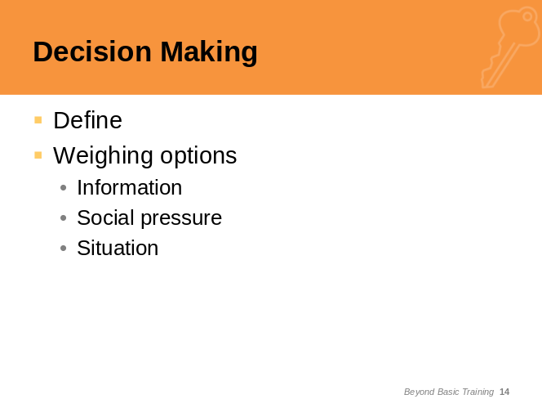

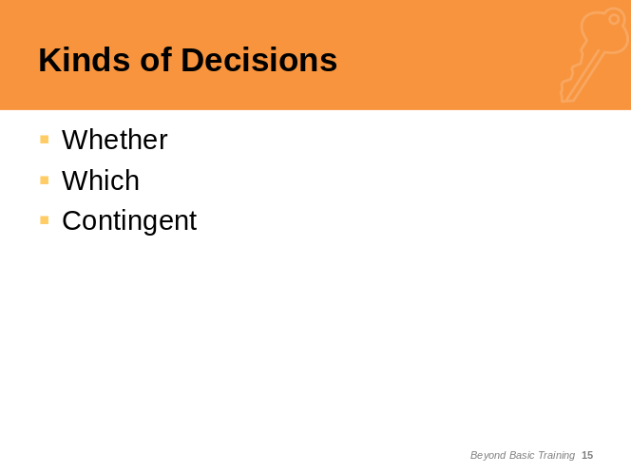

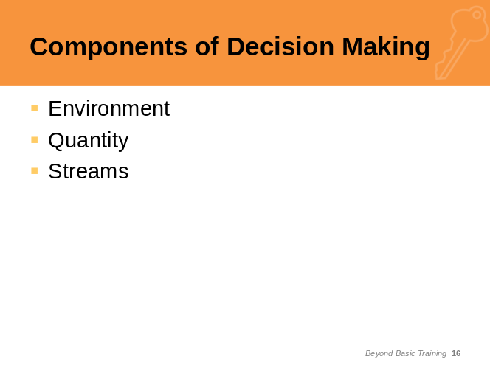

Internet DemonstratION: Tour of Plan My Move, http://planmymove.mhf.dod.mil, and MilitaryINSTALLATIONS, http://www.militaryinstallations.dod.mil.
Note: These are content rich websites. It is suggested that the following content from this website be demonstrated: the short tour calendar; the special needs calendar; the CONUS to OCONUS calendar view; and how to customize the calendars. Make sure to point out how to link to MilitaryINSTALLATIONS and Sponsorship links.

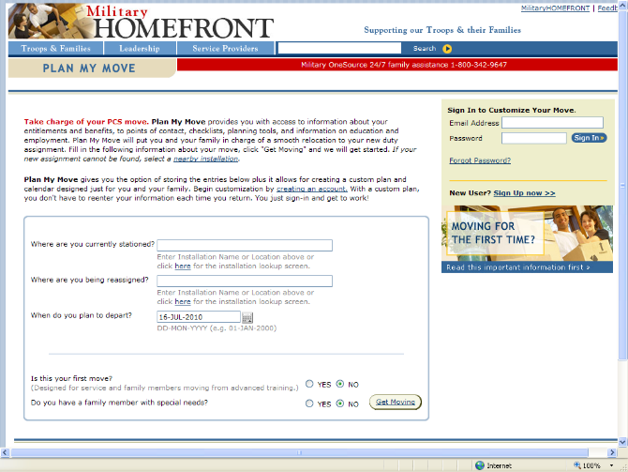



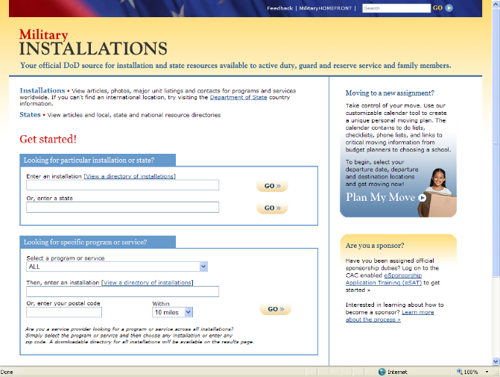
Internet DemonstratION: Tour of Military OneSource, http://www.militaryonesource.com
Make sure to stress that Military OneSource consultants are available 24/7/30 to assist with any questions or concerns. They can be found at http://www.militaryonesource.com or by phone at 1-800-342-9647. On the website there is a link to “Email a Consultant”. Deciding what content to demonstrate from the MOS website will depend on the audience. At a minimum demonstrate or show the homepage.
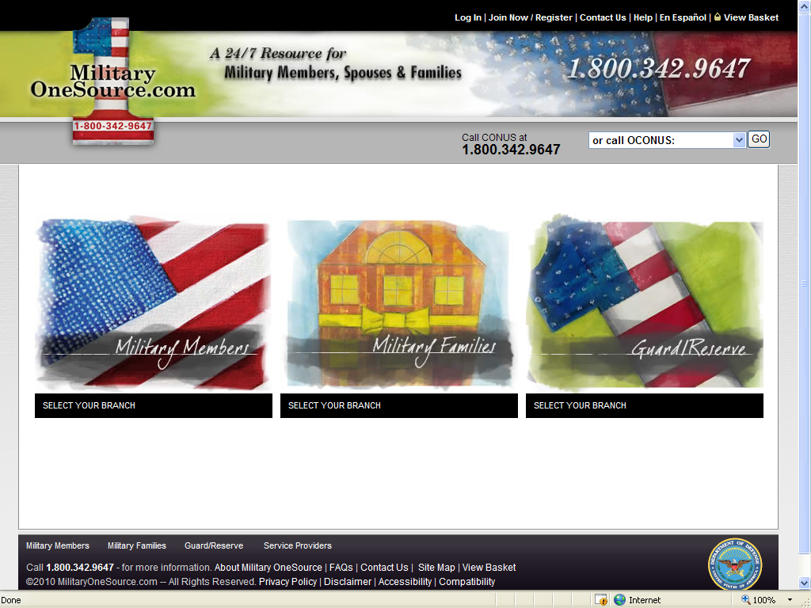

Transition Step: Remember that there are very few decisions that are irrevocable and you can always make the decision to do something else. We have discussed one of the larger life decisions in this chapter, Buying a Home, and how this is a major life decision. We have focused on something so big because it is a decision most of you will make at some point in your lives. Chances are when you make that decision it will be with a spouse or a significant other and the effective communication skills.

chapter 6
Communication Techniques
Attention Step: Good communication is the key to good relationships, buying a product or service, teaching children, talking with parents, and successful work. Actually, most of what we do all day every day requires communicating in some form or fashion. Clear communication is probably the most challenging of all communication skills because it involves knowing your audience and how they are going to “hear” what you are saying.

Instructor: You will find three exercises involving communication in Worksheet E, Effective Communication: Positive Communication, Non-verbal Communication and a test of your assertiveness. Depending on time, it is recommended that the participants work in teams and after each exercise discuss what they have learned.

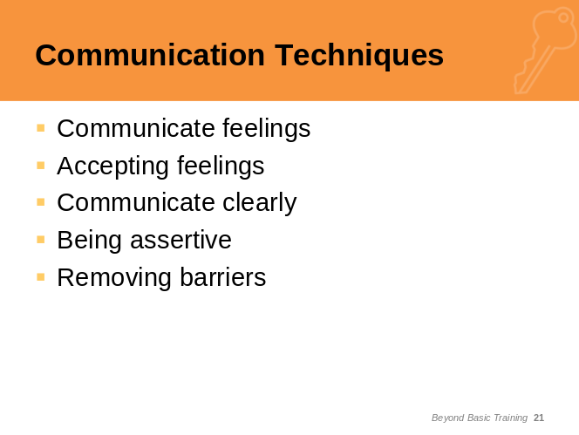

Transition Step: We have just scratched the surface of communication techniques in the short time we have had together, as well as only partially touching on the other concepts and Life Skills during our discussion today. There is a reference list at the end of your Student Manual which provides sources for more in-depth study and practicing these concepts.

Summary/Wrap Up

Attention Step: As we are almost out of time, let’s review your Expectations, our Objectives and determine if we have missed anything. Then we have (insert how much time is left) to take questions. Finally, we would like everyone to fill in the Evaluation, Worksheet F.
Note: Remember to make a list of any hand outs that you promised to the attendees.
Slide:
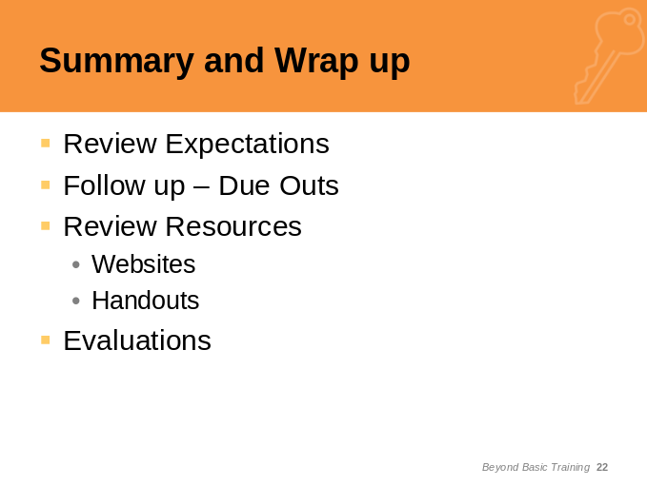

Handout: Evaluation, Worksheet F

Worksheets
- Self Esteem
- Values
- Goal Setting
- Decision Making Tools
- Effective Communication
- Evaluation Form

Worksheet A – Self Esteem
Instructions: Please fill in the questions below.
- List the many things I do successfully.

- Yes or No, I can improve my self-esteem by meeting my own expectations.

- Yes or No, I do not have to strive for perfection to approve of myself.

- My worth as a human being does not depend on achieving a perfect weight, or by being the smartest, or the most popular, or the fastest, or having the highest grades, or being the funniest, or having the coolest friends, or getting into the best school, or...

- The following statements are all true for people with high self esteem:
- I alone am responsible for the decisions I make
- I am a unique individual
- Persistence will help me succeed
- Every mistake I make can be an opportunity to learn. I can not be afraid to make mistakes; this is how I learn to improve
- I deserve support and will ask for help when I need it
- I have the power to forgive myself for past mistakes
- I will treat myself as someone special
- I determine what success means to me

Now you make up some of your own.

Worksheet B – Values

1. Rank Your Values
Instructions: Rank the following 15 items from your most important value to your least important value.
Values Rank
Making it on my own
Getting good grades/good evaluations
Preparing for my future
Getting along with my parents
Getting married
Living by my religion
Being artistic or creative
Making money
Being popular with my friends
Getting a job I really like
Being good in sports
Having children
Making new friends
Having my own car

2. Values Voting
Instructions: The statements below are read aloud and each person votes:
Agree, Disagree, or Unsure.
 |  | Agree | Disagree | Unsure
1 | You can get a good job without finishing high school.
2 | It is not what you know, but who you know that counts when it comes to getting a job.
3 | In a family, the man should be responsible for financial support.
4 | Using birth control is a woman’s responsibility.
5 | There’s no point in planning, since life is a game of chance.
6 | Men who father children should share the responsibility of caring for them.
7 | Teenagers should not have babies.
8 | It is okay for a man to cry.
9 | Having a job that you like is more important than making a lot of money.
10 | Male/female relationships were better off before the “women’s liberation” movement started.
11 | Women should not get jobs that men have always had.
12 | Teenage girls who get pregnant should give their babies up for adoption.
13 | A pregnant teenager has the right to decide whether or not she wants to have an abortion.
14 | A person who decides not to have children is selfish.
15 | A man who never becomes a father is not a real man.

3. Values and Vocations
Instructions: Here are some things that people might value and want to consider in choosing a job. Circle the three values that would be most important to you in choosing a job, and then put a line through the values that would not be important to you at all.
Helping other people | Having job security
Being creative or artistic | Being able to work when you want
Having a daily routine that  does not change much | Doing something that adds  beauty to the world
Earning a lot of money | Working outdoors
Becoming famous | Finding adventure
Working with people all the time | Being able to learn new things
Being able to influence  other people | Being known as an  intellectual or a “thinker”

Worksheet C – Goal Setting
1. Short-term Goals: My Contract
Instructions: Working in pairs, fill out your “contract” by:

- Writing in a short-term goal.
- Filling in date by which goal must be met.
- Talking over your goal with your partner and listing 3 objectives to achieve your goal.
- Signing; have your partner witness.

I, , being of healthy mind and body, do hereby declare my intention to achieve the following short-term goal on or before _____________.
(date)

My goal is to:

To achieve my goal, I will complete the following objectives:

Signed
Witnessed by
Date
2. My Ten-Year Class Reunion
Instructions: To answer these questions, think about what you would like to tell your friends when you see them again in ten years.

In ten years my age will be

My job will be (be as specific as possible)

To get my job, I had to

My specific responsibilities will be

My approximate annual income (or my family’s) will be

My most important personal possessions will be

My family responsibilities will be

I will tell my friends that of my experiences in the last five years, the best have been

Worksheet D – Decision Making Tools

1. Decision Making Guide
Instructions: Use this guide in making a decision concerning the dilemma presented by the instructor.

Step 1: Name the choices or alternatives involved in your decision.
a.
b.
c.

Step 2: Gather information about the decision. (Consider your personal values, your goals, and what facts you need to know.)

Step 3: List the advantages and disadvantages of each choice.

a. Alternative #1:
Advantages
Disadvantages

b. Alternative #2:
Advantages
Disadvantages

c. Alternative #3:
Advantages
Disadvantages

Step 4: Make your decision and list your reasons for this choice.

2. Force Field Analysis Form
Instructions: With the assigned problem from the instructor, develop a force field analysis.
Goal:

Driving Forces | QSE | Restraining Forces

Action Alternatives

Worksheet E – Effective Communication
1. Choose Your Words Carefully for Positive Communication
Instructions: Choose “I statements” in place of the sentences on this sheet.
1. You never call. | I wish you would call more often. (Example)
2. You are always late.
3. That’s a stupid idea.
4. Nobody in this place cares about my work.
5. You always ignore me when we go out.
6. Do not yell at me.
7. You should not do that.
8. It is not really important, but I wanted to talk to you.
9. I just know you are going to go back with your old girlfriend.

2. Non-Verbal Communication Introduction
Instructions: This entire exercise must be accomplished without words. In pairs, you are to introduce yourself to your partner. You may use visuals, signs, gestures, and pictures, but you may not draw or write; only point or act. After 2 minutes, check with your partner to see what was communicated, then switch and the other person is to introduce himself/herself to his/her partner.
3. Test Your Assertiveness
Instructions: Check the box appearing by each statement that applies to you.
 | Almost Never | Some of the Time | Most of the Time
I can express my feelings honestly.
I can say “no” without apologizing or feeling guilty.
I can admit when I’m angry.
I try to find out the cause of my anger.
I wait to have all the facts before I make decisions.
I criticize a person’s behavior, not the person.
I take responsibility for my own feelings instead of blaming others.
I make it a point to express good feelings, as well as bad.
When I say how I feel, it’s not at someone else’s expense.
If I disagree with someone, I do not use verbal or physical abuse.
I offer solutions to problems instead of just complaining.

Worksheet F – Evaluation
- Was this workshop helpful?

- What information did you find most helpful?

- What information did you find least helpful?

- What additional information would you like to have incorporated in future workshops?

- Is the workbook helpful?

- Additional comments:

Reference List

Publications
Branden, Nathaniel. The Psychology of Self-Esteem. Nash Publishing Corporation, 1969.
Goldstein, Kurt. The Organism: A Holistic Approach to Biology Derived from Pathological Data in Man. 1934. New York: Zone Books, 1995.
Maslow, Abraham H. "A Theory of Human Motivation." Psychological Review 50, 1943: 370-396.
Maslow, Abraham H. Motivation and Personality. 1954. Ed. Cynthia McReynolds. 3rd ed. New York: Harper and Row, Inc., 1987.
Maslow, Abraham H. The Psychology of Science. Gateway Edition 1.95 ed. Chicago: Henry Regnery Company, 1969.
Raths, L., Harmin, M., & Simon, S. Values and teaching: Working with values in the classroom (2nd ed.). Columbus, OH, 1978.

Websites
Abraham Maslow’s website: http://www.abraham-maslow.com/m_motivation/Hierarchy_of_Needs.asp.
Livestrong.com: http://www.livestrong.com/article/13925-self-esteem
MilitaryINSTALLATIONS: http://www.militaryinstallations.dod.mil
Military OneSource: http://www.militaryonesource.com
Mind Tools: http://www.mindtools.com
Nathaniel Branden’s website: http://www.nathanielbranden.com/catalog/index.php
Plan My Move: http://planmymove.mhf.dod.mil
VirtualSalt: http://www.virtualsalt.com/crebook5.htm





Providing policy, tools, and resources to service members and their families.

