# Far Away Places Instructor Guide Cover ImageRelocation Assistance Program Far Away Places Workshop Instructor Manual

***Updated December 2013***

# Table of Contents

Workshop Setup and Overview 1

Audience 1

Timing 1

Workshop topics 1

Materials 2

Presenter 2

Tips on using this guide 3

Begin Workshop 4

Welcome 4

Objectives of the workshop 6

Chapter 1 Adaptation 7

chapter 2 Planning Your Relocation 12

chapter 3 Special Considerations – Moving Overseas 15

Summary 20

Worksheets 21

Worksheet 1 - *Cultural Assumptions and Values Affecting Interpersonal Relationships* 22

Worksheet 2- *International Gesture Dictionary* 31

Worksheet 4 *-* *Scavenger Hunt for Facts* 38

Worksheet 5 - *Evaluation* 40

Checklists 41

Important Documents to Hand-Carry 42

Pre-Departure Checklist for Overseas Moves 44

Practical Checklist for Arrival in New Location 48

References 54

# FAP ChpStripWorkshop Setup and Overview

This workshop contains an Instructor’s Guide, a Student Manual, and worksheets and PowerPoint slides supporting the workshop. This workshop provides participants with the tools and knowledge necessary to make efficient and cost-effective overseas moves when they receive permanent change of station orders. It is designed to walk participants through many important issues from preparing for a move through settling into a new assignment overseas. These steps include understanding issues surrounding preparing a family for an overseas move, culture shock and the entitlements available when moving overseas.

## Audience

The audience for this workshop includes service and family members with PCS orders and those expecting orders in the near future. This workshop can be used with DoD civilians as well as uniformed members. The suggested size for the workshop is 20 participants.

## Timing

Please note that this workshop can be expanded or condensed depending on available time. It can be broken into many different workshops, for example, country-specific workshops for groups moving to Germany, Korea or other countries, individuals who are considering an overseas tour or for new arrivals overseas who want to investigate ways of adapting quickly or alleviating feelings of isolation. The amount of information you or the instructor feels comfortable presenting will determine the amount of time needed for the workshop as well as how many Internet demonstrations are included. Suggested timing is two hours.

## Workshop topics

* Adaptation and culture shock
* Planning for an overseas move
* Special considerations for moving overseas

## Materials

* Tables and chairs
* Name tags for all participants
* Sign-in sheet
* PowerPoint-capable computer and projector with screen
* PowerPoint slide presentation
* Internet compatible computer with connectivity
* White board with markers or chart paper with markers
* Handouts
* Worksheet 1 - Cultural Assumptions and Values Affecting Interpersonal Relationships
* Worksheet 2 - International Gesture Dictionary
* Worksheet 3 - Language
* Worksheet 4 - Scavenger Hunt for Facts
* Worksheet 5 - Evaluation
* Checklists
* Important Documents to Hand-Carry
* Pre-Departure Checklist for Overseas Moves
* Practical Checklist for Arrival in New Location
* Reference list

## Presenter

This workshop lends itself best to a presenter who has some expertise in the following:

* Military and DoD civilian PCS overseas moves
* Relocation with knowledge of cultural adaptation

## Tips on using this guide

The Instructor’s Guide is designed with an Attention Step to introduce each section. This step is an overview and introduction to the section. At the end of the section, there is a Transition Step to the next section.

There are notes placed throughout with instructions for the presenter. These are tips to help facilitate the workshop and many suggested exercises that correspond to the worksheets.

The Instructor’s Guide contains the attachments from the Student Manual. In this kit, the reference list offers additional resources.

The Internet demonstrations are optional depending on connectivity. It is recommended that, if there is no connectivity, the workshop slides be augmented with additional screenshots. If there is connectivity, remember to have the websites open to the pages used during the presentation.

The content is all contained in the Student Manual. The presenter must read and be thoroughly familiar with the content in order to present this workshop.

# Begin Workshop

**Host:** Introduce the instructor, if there is one presenting this workshop, or begin the workshop with the welcome.

## Welcome

**Instructor:** Welcome the participants and provide them with some details about your background. Tell the participants your name, title, your experience relocating with the military and your expertise in cultural adaptation. If the group is not too large, ask the participants to state their names, backgrounds and their moving plans. You can also ask, by a show of hands, how many have a family budget and update it religiously or how many are interested in learning how to budget for a move.

Write the word **NEAT** on the white board or chart paper and explain the meaning:

**(N)ature** – The workshop is interactive and participants are encouraged to voice their ideas, concerns, questions and experiences.

**(E)xpectations –** As the participants brainstorm, list their ideas on the white board or chart paper. Keep these visible so they can be readdressed at the conclusion of the workshop. This discussion gives the instructor insight into which areas to focus the workshop discussion and the experience level of the participants with the subject matter.

**(A)genda –** The agenda is presented according to the objectives listed in the PowerPoint presentation, but may be modified to fit time and expectations.

**(T)iming –** The timing is presented by the instructor.

* Write out on the white board or chart paper approximately when the breaks will occur.
* Provide the location of the restrooms.
* Offer coffee or snacks if provided.
* Remind participants to sign in.
* Briefly review the Student Manual, worksheets, checklists and reference attachments to make sure each participant has the proper materials. This workshop contains:
* Worksheet 1 - Cultural Assumptions and Values Affecting Interpersonal Relationships
* Worksheet 2 - International Gesture Dictionary
* Worksheet 3 - Language
* Worksheet 4 - Scavenger Hunt for Facts
* Worksheet 5 - Evaluation
* Checklists
* Important Documents to Hand-Carry
* Pre-Departure Checklist for Overseas Moves
* Practical Checklist for Arrival in New Location
* Reference list including recommended websites

Note: Make available and explain any additional resources available for the participants to view during breaks or at the conclusion of the workshop. Also, keep to the times announced; this makes participants more comfortable and encourages participation.

Slide:



## Objectives of the workshop

Now that you have the participants’ full attention take a moment to briefly review the objectives of the workshop:

* What is culture shock?
* What is the intercultural adjustment cycle?
* What are some skills necessary for adaptation?
* How should you plan for international relocation?
* What are the financial aspects of an international relocation?
* How can you gain some insight into cultural differences?

Add these objectives to the expectations that were brainstormed with the group earlier. Close out the introductory portion with a comparison of the objectives to the expectations and summarize the other points you will discuss as part of this workshop or materials you will collect and forward after the workshop.

SlidE:

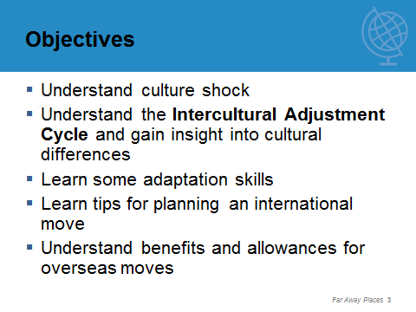

# Chapter 1 Adaptation

Attention Step: Moving is a complex process and one that requires careful planning. The process becomes more complex when moving away from family and friends to a culture based on different values. It all begins with the preparation for the overseas move. The relocation assistance program in the military and family support center has resources to assist the military members and families plan international moves and adapt to the new cultures.

**Instructor:** Begin with brainstorming a list of things they will need to do to prepare for an overseas move. Address the psychological as well as logistical needs of each family member.

Note: During the discussion of this part of the workshop, make sure to point out how the checklists can be used by the participants to help organize and plan their move.

Slides:

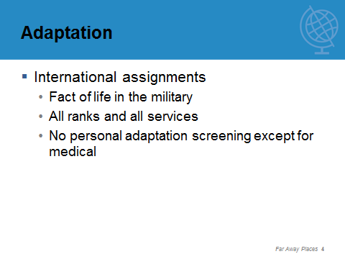

**Stress screen shot**



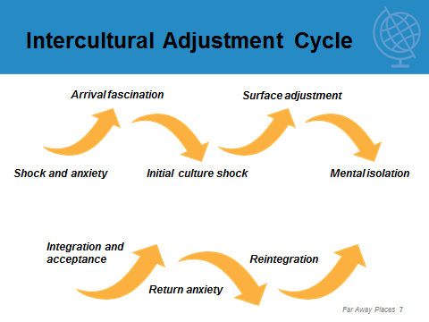

**Instructor:** Direct participants to Worksheet 1 (Cultural Assumptions and Values Affecting Interpersonal Relationships**)** and review several of the attitudes portrayed in Rhinesmith’s work on American values versus other cultures. Discuss the impact these attitudes can have on a move.



**Instructor:** Point to Worksheet 2 (International Gesture Dictionary) and Worksheet 3 (Language). Go around the group and have everyone take one topic and discuss items in Worksheet 2. Next go over the language worksheet and discuss the ways one might learn a bit of the new language before arriving in their new country.

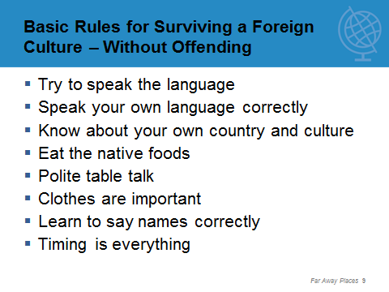

**Instructor:** Spend about 10 minutes and assign each person or each team a country for Worksheet 4 (Scavenger Hunt for Facts). Ask them to fill in the worksheet for their country and then discuss as a group.

Internet DemonstratION: **Tour of CIA Factbook**[www.cia.gov/library/publications/the-world-factbook/](http://www.cia.gov/library/publications/the-world-factbook/)

***Note:*** Because there is so much information on the Internet, if participants only have time for one or two online searches, the CIA World Factbook and the Department of State’s Travel section are the most comprehensive published today.

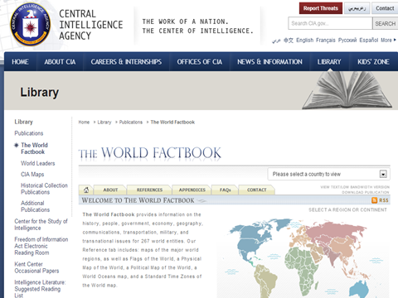

Internet DemonstratION: **Tour of State Department Travel page**  [www.state.gov/travel](http://www.state.gov/travel)

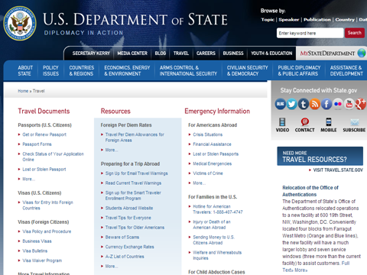

Select Countries and Regions from the blue bar at the top of the page.

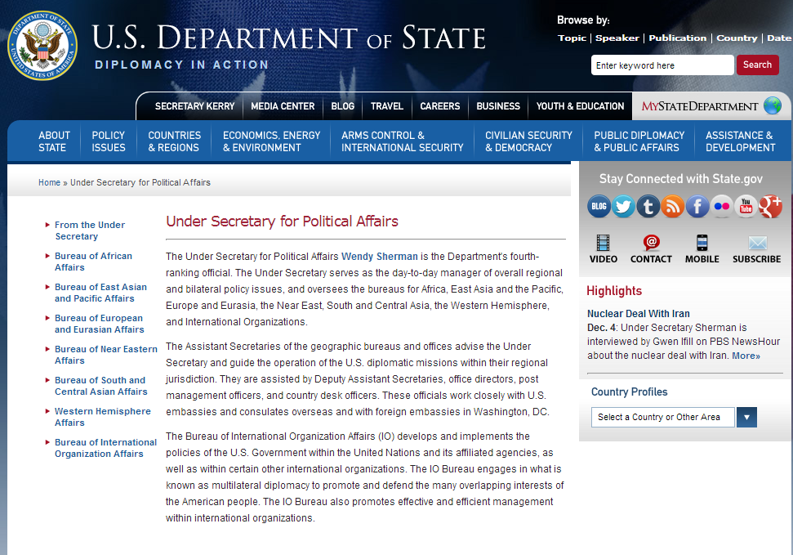

Select A-Z List of Country and Other Area Pages to find the destination location

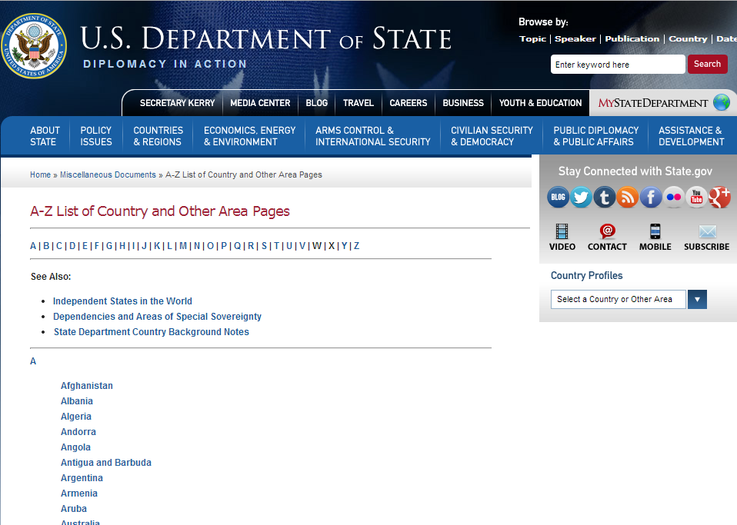

***Note:*** If time allows, a fun exercise is to divide the group into three smaller groups and have each write as many names of countries in the regions they are assigned. Allow five minutes, then discuss as you talk about each country.

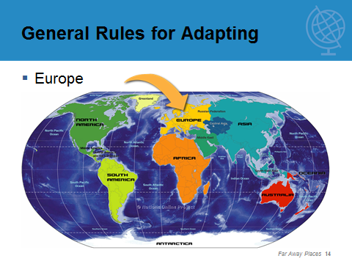

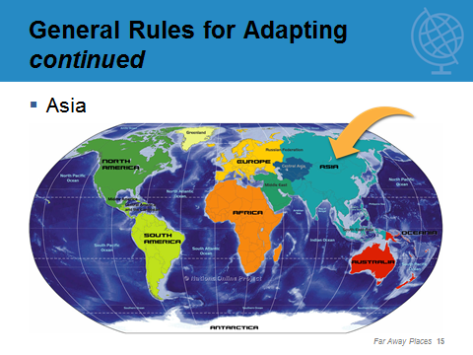

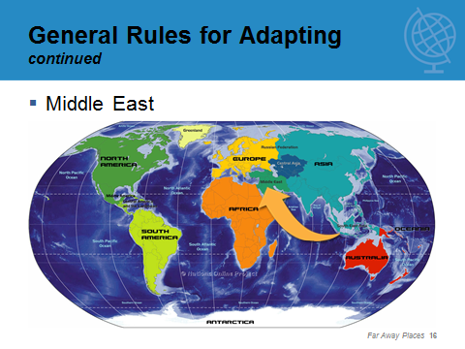

**Instructor:** Summarize this part of the discussion with another brainstorming exercise on the importance of understanding how our values affect our perceptions of other cultures and how they impact our ability to adapt.

Transition Step: The military provides access to information. It is up to us to interpret the information and apply it to our family situation when faced with an overseas move. Planning for that move is critical to its success.

# chapter 2 Planning Your Relocation

Attention Step: Every move is unique, just as every family situation is unique in some way. These unique situations make giving advice on planning for a move challenging. However, two major factors are present in every move that need to be addressed as they can have significant impact on your budget, your time and your stress level.

Slides:

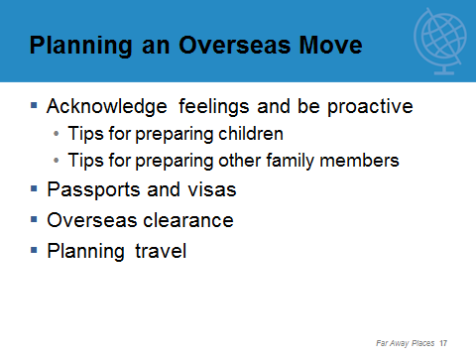

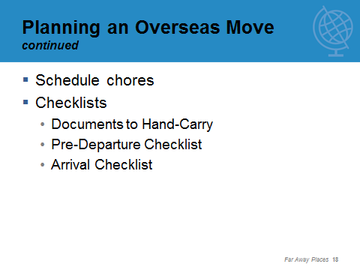

Note: Discuss the three checklists at the end of the Student Manual and brainstorm any items that might be added to these checklists. Emphasize how important it is to make lists and check them off when the task is complete.

Internet DemonstratION: **Tour of Plan My Move** [http://planmymove.militaryonesource.mil](http://planmymove.militaryonesource.mil/)

Note: This is a content-rich website. You may want to demonstrate the short-tour calendar, special needs calendar, CONUS to OCONUS calendar view and the customization feature. Make sure to point out links to MilitaryINSTALLATIONS and sponsorship.

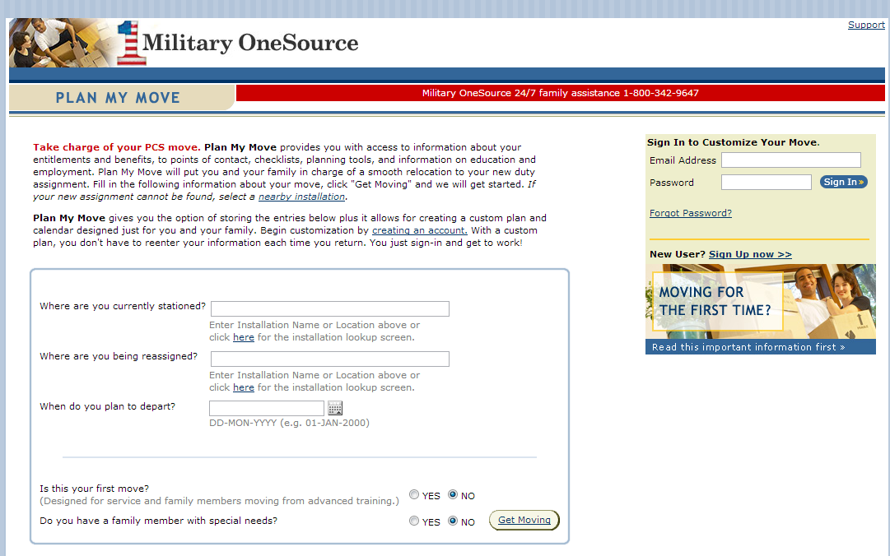

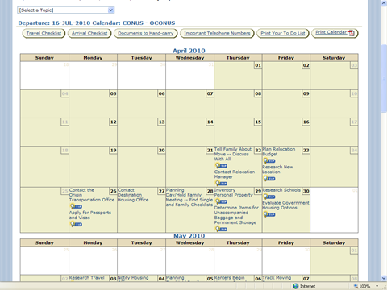

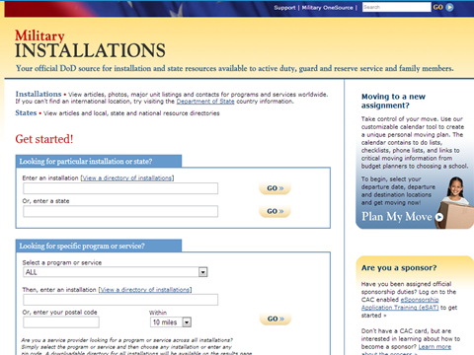

Internet DemonstratION: **Tour of Military OneSource**<http://www.militaryonesource.mil/on-and-off-base-living/moving>

Note: Consider scrolling down to the OCONUS Moves section and choose several articles depending on your audience. Make sure to stress that Military OneSource consultants are available 24/7 to assist with any questions or concerns. Find them by visiting [www.militaryonesource.mil](http://www.militaryonesource.mil), by calling 800-342-9647 or by email.

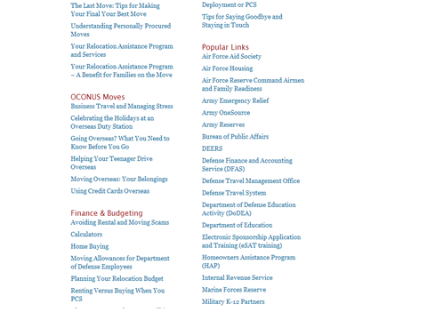

Transition Step: Good planning for the physical part of the move is only half the battle; the other half is financial planning, including knowing your allowances and your budget.

# chapter 3 Special Considerations – Moving Overseas

Attention Step: Planning for a move includes understanding your military entitlements, the impact of losing your spouse’s income and a moving budget. The military has a long list of reimbursements associated with a PCS move. The Defense Travel Management Office is the official source of information. Be sure to check the user-friendly site often if you have questions. Your personal financial management office will also use this website to answer questions regarding moving reimbursements.

**Instructor:** Discuss the various allowances using the following slides. You should make a point to have illustrations for some of the more complex allowances such as DLA, TLE and TLA.

Slides:

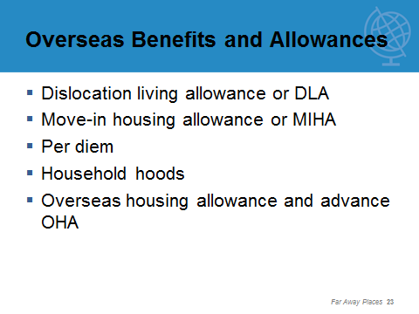

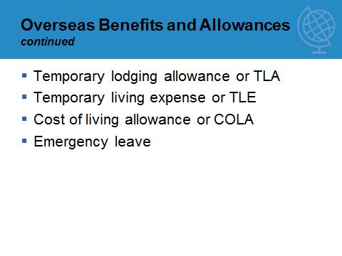

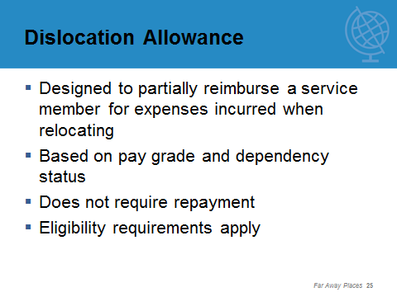

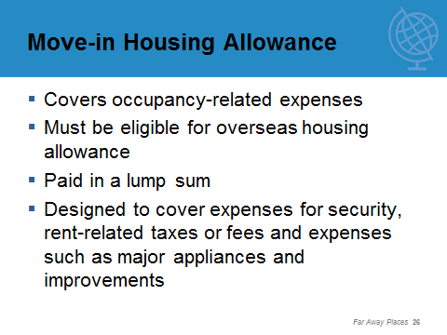

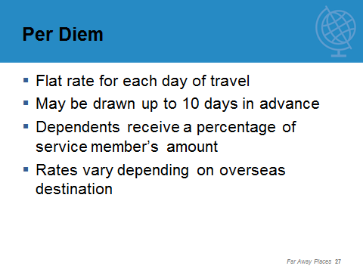

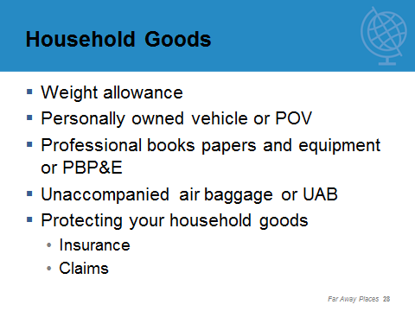

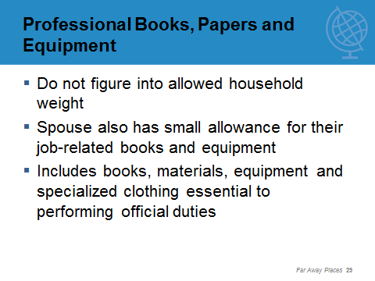

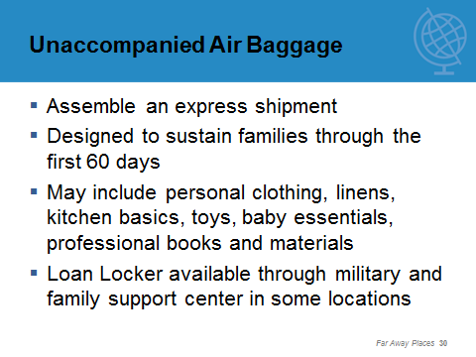

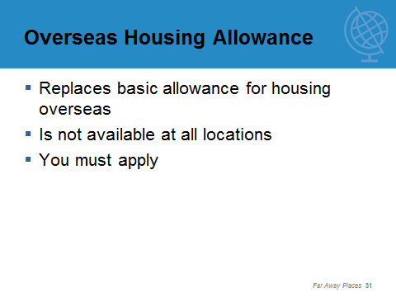

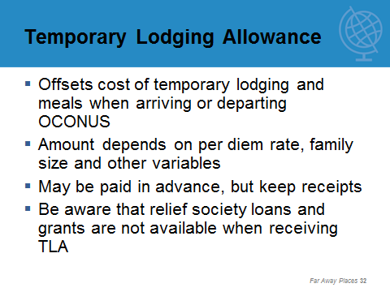

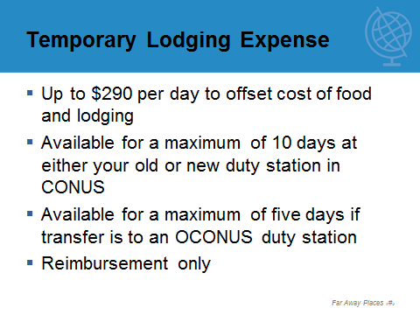

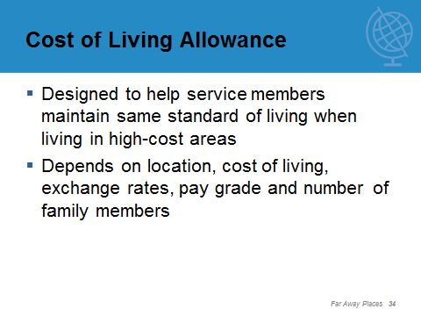

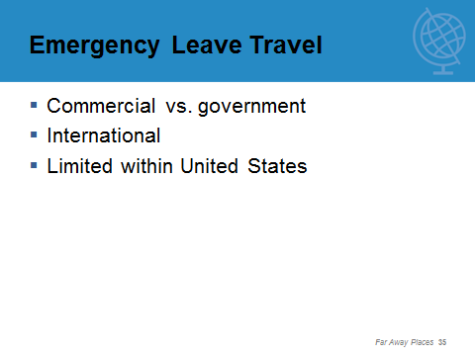

Internet DemonstratION: **Tour of Defense Travel Management Office website** [www.defensetravel.dod.mil/site/allowances.cfm](http://www.defensetravel.dod.mil/site/allowances.cfm)

Note: This is a content-rich website. You may want to demonstrate how to find a per diem rate, frequently asked questions and one or two of the other allowances.

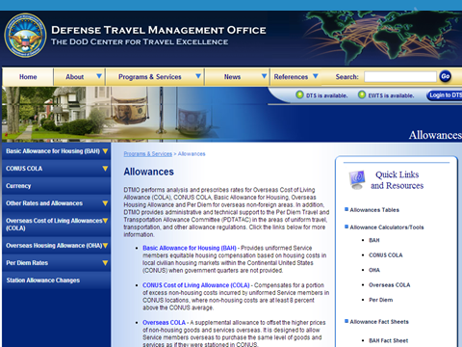

**Instructor:** Since family member employment has a direct and real impact on family finances, it also affects emotions and attitudes toward the move. It is important to discuss the SOFA and its impact on employment, then discuss volunteer opportunities and education options.

**SLIDE:**

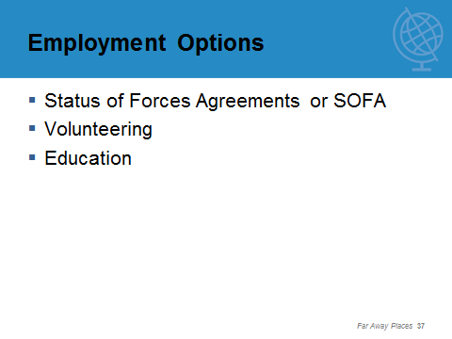

Transition Step: We know that taking in all the information on allowances and benefits is a lot to digest in one sitting, so we ask you to remember the two most important things: Always check the Defense Travel Management Office website for the current information, and refer to your Student Manual when you have questions.

**chapter 4**

# Summary

Attention Step: A lot of information was presented today. Let’s first review your expectations and our objectives and determine if we have missed anything. Then we have (insert how much time is left) to take questions. Finally, we would like everyone to fill in the Evaluation, Worksheet 5.

Note: Remember to make a list of any handouts that you promised to the attendees.

Slide:

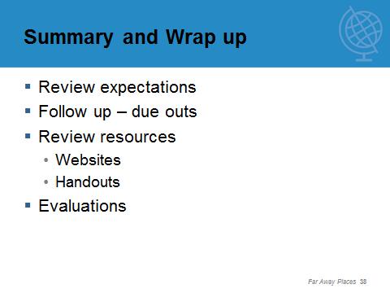

# Worksheets

1. Cultural Assumptions and Values Affecting Interpersonal Relationships
2. International Gesture Dictionary
3. Language
4. Scavenger Hunt for Facts
5. Evaluation

## Worksheet 1 - *Cultural Assumptions and Values Affecting Interpersonal Relationships*

This information was collectively adapted from Stephen Rhinesmith’s work, 1970 to 2010.

|  |  |
| --- | --- |
| Value | **Assumption Example** |
| A = | Assumption or value held by majority of Americans |
| C - A= | Assumption or value held by majority of persons of a contrast-American society or one that is in contrast to American society in its assumptions and values |

**DIRECTIONS:**Circle the value that most represents your attitude for each of the questions below.

### 1 - How do we see ourselves?

#### What is our primary identification?

|  |  |
| --- | --- |
| Value | **Assumption** |
| A | Within ourselves as individuals |
| C - A | As part of a family, clan, caste or tribe |

#### What do we value in people?

|  |  |
| --- | --- |
| Value | **Assumption** |
| A | What people can achieve through special skills |
| C - A | A person’s background, family connections or tribal affiliations |

#### Who do we rely on for help?

|  |  |
| --- | --- |
| Value | **Assumption** |
| A | Ourselves as independently resourceful people |
| C - A | Our friends, family and others owing us obligations |

#### How do we learn about life?

|  |  |
| --- | --- |
| Value | **Assumption** |
| A | From personal experience |
| C - A | From wisdom and knowledge of others |

#### What is the basis of social control in a community?

|  |  |
| --- | --- |
| Value | **Assumption** |
| A | From feelings of guilt because we are not living up to our personal standards |
| C - A | From feelings of shame because we are not living up to the standards of our community |

### 2 - How do we see our relationship with others?

**How do we relate to people of different status or authority?**

|  |  |
| --- | --- |
| Value | **Assumption** |
| A | Minimize the difference |
| C - A | Stress the difference; show respect for authority and position |

**How do we relate to new acquaintances?**

|  |  |
| --- | --- |
| Value | **Assumption** |
| A | Stress informality; make people feel at home |
| C - A | Stress formality; act properly in front of strangers |

**How do we idealize work and sex roles?**

|  |  |
| --- | --- |
| Value | **Assumption** |
| A | Little differentiation between male and female roles |
| C - A | Distinct and rigid differentiation between male and female roles |

**How do we idealize sex roles and friendship?**

|  |  |
| --- | --- |
| Value | **Assumption** |
| A | People may have close friends of both sexes |
| C - A | People may have close friends of same sex only |

**How do we idealize sex roles in social relationships?**

|  |  |
| --- | --- |
| Value | **Assumption** |
| A | Sexual equality for males and females |
| C - A | Male superiority |

**What are our loyalties to organizational life?**

|  |  |
| --- | --- |
| Value | **Assumption** |
| A | Move easily from one organization to another when our personal goals are not fulfilled |
| C - A | Remain with our organization from sense of loyalty even when personal goals are not fulfilled |

#### What are the characteristics of friendship?

|  |  |
| --- | --- |
| Value | **Assumption** |
| A | A loose concept applied to many people and based on overlapping special interests with limited obligations to one another |
| C - A | A specific concept applied to a few people; total involvement based upon mutual love and respect with unlimited obligations to one another |

**How do we deal with conflict?**

|  |  |
| --- | --- |
| Value | **Assumption** |
| A | Favor eye-to-eye confrontation between two people disagreeing |
| C - A | Find it unacceptable and embarrassing |

**How do we regard kidding or joking at the expense of others?**

|  |  |
| --- | --- |
| Value | **Assumption** |
| A | As acceptable, interesting and fun |
| C - A | As unacceptable and embarrassing |

**Where are our primary ways of social interaction with friends?**

|  |  |
| --- | --- |
| Value | **Assumption** |
| A | Doing things together |
| C - A | Being together |

**What is the preferred pace of life?**

|  |  |
| --- | --- |
| Value | **Assumption** |
| A | Fast, busy, conducive to getting things done |
| C - A | Slow, steady, conducive to getting the most from life |

### 3 - How do we see the world?

**What is nature like?**

|  |  |
| --- | --- |
| Value | **Assumption** |
| A | Physical, proven by scientific investigation |
| C - A | Spiritual and mystical |

**How do natural forces in the world operate?**

|  |  |
| --- | --- |
| Value | **Assumption** |
| A | In a rational, controllable manner |
| C - A | In a predetermined, spiritually controlled manner |

**What is the role of fate in life?**

|  |  |
| --- | --- |
| Value | **Assumption** |
| A | It has little influence; we are the masters of our destiny |
| C - A | It has great influence; there is little we can do to alter it |

**What is the relationship between man and nature?**

|  |  |
| --- | --- |
| Value | **Assumption** |
| A | Man should modify nature for his own need |
| C - A | Man should accept and integrate with the natural forces around him |

**How do we look at time?**

|  |  |
| --- | --- |
| Value | **Assumption** |
| A | In precise minutes and hours by which we organize our days |
| C - A | In diffuse minutes and hours by which we organize our days |

**How do we value time?**

|  |  |
| --- | --- |
| Value | **Assumption** |
| A | As a limited resource not to be wasted |
| C - A | As an unlimited resource to be used |

**How does life unfold?**

|  |  |
| --- | --- |
| Value | **Assumption** |
| A | In a lineal fashion through history |
| C - A | In a cyclical fashion through recurring seasonal patterns |

**How do we measure progress?**

|  |  |
| --- | --- |
| Value | **Assumption** |
| A | In concrete, quantifiable units, which indicate amount, size, percent and the like |
| C - A | Against abstract social and moral principles of our society |

**On what basis do we make decisions?**

|  |  |
| --- | --- |
| Value | **Assumption** |
| A | Will it work? |
| C - A | Is it right? |

## Worksheet 2- *International Gesture Dictionary*

The following excerpt from *Dos and Taboos Around the World* by Roger E. Axtell gives some very good examples of varying interpretation of common American gestures.

| Gestures Using the Face | |
| --- | --- |
| **Wink** | It is considered flirting in some areas, and in other areas it means, “I’m only kidding.” It is considered improper in Australia. |
| **Eyelid pull** | Pulling out the eyelid at the corner in Europe and some Latin American countries means “be alert” or “I am alert.” |
| **Eyebrow raise** | In Tonga, it means “yes” or “I agree.” In South America, it can mean “pay me.” In some parts of Europe, it means, “I am skeptical” or “I find that hard to believe.” |
| **Blink** | In Taiwan, blinking an eye may be considered rude. |
| **Flicking the ear** | A flick of the earlobe in Italy may mean, “That gentleman is effeminate.” |
| **Stroking the cheek** | It means “attractive” in Greece, Italy and Spain. In Yugoslavia, it means “success.” In other places, it may mean “ill” or “thin.” |
| **Tapping the nose** | A nose tap in Britain signifies secrecy or confidentiality; in Italy, however, it means a gentle warning. |
| **Kissing the fingertips** | It means “ah, beautiful” or “I approve” in most European countries. |
| **Circling the ear with the finger** | This means “crazy” in most countries, but in the Netherlands it means someone has a telephone call. |
| **Flicking the chin** | This can mean “not interested” or “buzz off” in Italy. In some South American countries, it means, “I don’t know.” |
| **Thumbing the nose** | It signifies mockery in most of Europe. It can be made with both hands for double effect. |
| **Tossing the head back** | This can be a negative in Italy and Greece. In Germany and Scandinavia, it means, “Come over here.” |
| **Tapping the head** | “I’m thinking” in South America. In other places, it can mean “crazy.” |

|  |  |
| --- | --- |
| Hand and Arm Gestures | |
| **V sign** | With palm facing away, it means “victory” in most of Europe. The same gesture, with palm inward, is a rude gesture in Britain. In other countries, it signifies “two,” as in “two more beers, please.” |
| **Circling the thumb and forefinger** | It means “OK” in the United States, but is considered vulgar in Brazil. In Japan, it means “money” and in France, it signifies “zero” or “worthless.” |
| **Snapping the fingers** | In France and Belgium, finger snapping has a vulgar meaning. |
| **Crossing the fingers** | In most of Europe, this means “protection” or “good luck.” In Paraguay it may be considered offensive. |
| **Beckoning** | Using the finger or fingers to call someone can be construed as an insult in the Middle East and Far East. In these countries, as well as in Spain and Portugal, you should put your hand palm down and wave the fingers or whole hand to beckon someone. |
| **Thumbs up** | In most areas of the world, this means “OK,” but in Australia, it is considered rude. |
| **Pursing all fingers together** | Almost the national gesture of Italy, it can signify either a question, something good or something to fear. |

|  |  |
| --- | --- |
| **Third finger thrust** | Not nice in any language |
| **Other vulgar gestures to avoid** | Fist slap, forearm jerk, palm push |
| **Waving** | This is a serious insult in Greece; the closer the hand to the person’s face, the more threatening. In Europe, raise palm outward and wag all fingers together to say “goodbye.” Waving the hand back and forth can mean “no.” |
| **Waving in Japan** | Moving your hand forward and backward with the fingers together and the thumb toward your face signifies “yes.” “No” is indicated by the same hand position, but moving it left and right in front of your face. |
| **Tapping the elbow** | In Holland, this means, “He’s unreliable.” In South America, it can mean, “You’re stingy.” |

Worksheet 3 *-* *Language*

**DIRECTIONS**: Write down the actual spelling of the word in the language of your destination country, and, beside it if possible, write the phonetic pronunciation. Practice saying the words as you write them down. Practice them with the family during family meetings or dinner times.

What is the native language called in the native language?

How do you say, “Do you speak English?”

Greetings:

#### How do you say ...?

Hello

Good morning

Good evening

Goodnight

##### Counting

1

2

3

4

5

6

7

8

9

10

11

12

13

14

15

16

17

18

19

20

21

22

23

24

25

26

27

28

29

30

40

50

60

70

80

90

100

200

1000

How are you?

I am fine

My name is

What is your name?

Speak slowly please

Please

Thank you

You’re welcome

Excuse me

##### Where is the ... ?

Toilet

Bath

Train station

Post office

Hotel

Restaurant

American embassy

Telephone

How much is this?

I do not understand

Do you understand?

What time is it?

I want to go to

I am hungry

May I see a menu?

I would like

Waiter

Check, please

The local toast; “cheers”

Goodbye

## Worksheet 4 *-* *Scavenger Hunt for Facts*

**DIRECTIONS:** Fill in the blanks with appropriate responses for your destination country. Take this home and study them with your family. You might want to learn a new phrase at dinner each night or practice exchanging money.

What is the unit of currency in the country?

What smaller units make up one of the larger unit? (For example, 10 dimes, four quarters or 20 nickels make up a dollar.)

______________________________________________________________________

What is the capitol city of the country?

Where is the country located geographically? (What countries or bodies of water border it?)

What are some of the popular foods in this country?

What is the climate like?

What are the favorite sports?

Name some of the major holidays.

What are the major industries?

What is the native costume?

Name some native customs which are different from American customs.

What are the customs regarding tipping?

## Worksheet 5 - *Evaluation*

1. Was this workshop helpful?

1. What information did you find most helpful?

1. What information did you find least helpful?

1. What additional information would you like to have incorporated in future workshops?

1. Is the workbook helpful?

1. Additional comments

# Checklists

* Important Documents to Hand-Carry
* Pre-Departure Checklist for Overseas Moves
* Practical Checklist for Arrival in New Location

## Important Documents to Hand-Carry

|  |  |
| --- | --- |
| **Document** | **Check** |
| Adoption papers (if applicable); remember court-ordered name changes |  |
| Allotment records (copy of allotment application) | When printed, check this box accordingly |
| Birth certificates (original or certified copies) for all family members | When printed, check this box accordingly |
| Bank statements (checking and savings) | When printed, check this box accordingly |
| Car insurance, registration, title | When printed, check this box accordingly |
| Checks: blank, canceled, current statement | When printed, check this box accordingly |
| Child ID file | When printed, check this box accordingly |
| Credit cards | When printed, check this box accordingly |
| Deeds and mortgages | When printed, check this box accordingly |
| Divorce papers (if applicable) | When printed, check this box accordingly |
| Driver's licenses | When printed, check this box accordingly |
| Educational report cards and records, Individual Education Plan documentation (if applicable), transcripts from schools attended, addresses and phone numbers of these schools | When printed, check this box accordingly |
| ID cards (for all family members 10 years of age and older) | When printed, check this box accordingly |
| Insurance policies (include the company, address, phone number, policy number and type of insurance) | When printed, check this box accordingly |
| Immunization records | When printed, check this box accordingly |
| Last LES (leave and earnings statement) | When printed, check this box accordingly |
| Lists of bonds, mutual funds, stocks and other investments (include broker’s address, phone number and account number) | When printed, check this box accordingly |
| List of payments due for household (due dates, account numbers, phone numbers, websites and addresses to avoid delinquent payments) | When printed, check this box accordingly |
| Marriage certificate | When printed, check this box accordingly |
| Medical records and shot records | When printed, check this box accordingly |
| Moving documents for unaccompanied baggage and household goods | When printed, check this box accordingly |
| Orders (three extra copies) | When printed, check this box accordingly |
| Original wills | When printed, check this box accordingly |
| Passports and visas (if needed, for all family members) | When printed, check this box accordingly |
| Personal papers (others than listed above) | When printed, check this box accordingly |
| POV shipping documents | When printed, check this box accordingly |
| Power of attorney (check expiration dates) | When printed, check this box accordingly |
| Safety deposit box key(s) | When printed, check this box accordingly |
| Spouse resume, letters of recommendation, records of employment, copies of personnel actions (for example, step increases or change of career status received from the personnel office) | When printed, check this box accordingly |
| State and federal income tax forms and records (last three years) | When printed, check this box accordingly |
| Social Security cards for all family members | When printed, check this box accordingly |
| Travelers checks | When printed, check this box accordingly |
| U.S. savings bonds | When printed, check this box accordingly |
| W-2 forms | When printed, check this box accordingly |

## Pre-Departure Checklist for Overseas Moves

### Travel arrangements

|  |  |
| --- | --- |
| **Activity** | **Check** |
| Confirm lodging reservations | When printed, check this box accordingly |
| Confirm travel reservations | When printed, check this box accordingly |
| Decide where you will eat your meals in advance of travel | When printed, check this box accordingly |
| Keep important phone numbers handy, such as emergency relief | When printed, check this box accordingly |
| Check weather en route or at destination | When printed, check this box accordingly |
| Provide itinerary information to friends and family | When printed, check this box accordingly |
| Make sure you have valid visas and passports | When printed, check this box accordingly |
| Make sure your ID card(s) are up to date | When printed, check this box accordingly |
| Pet travel requirements | When printed, check this box accordingly |

### Preparation for packing

| **Activity** | **Check** |
| --- | --- |
| Prepare first aid kit (band aids, aspirin, prescription medications, antacids, laxatives, antibiotic cream, insect repellant, sunscreen, towelettes, ear plugs, sewing kit) | When printed, check this box accordingly |
| Locate maps, print driving directions for trip or to and from airports | When printed, check this box accordingly |
| Locate reading material | When printed, check this box accordingly |
| Locate business cards | When printed, check this box accordingly |
| Locate video camera and charger for camera – recharge camera, pack charger and any cables to hand-carry | When printed, check this box accordingly |
| Locate camera, get chip or other recording device | When printed, check this box accordingly |
| Locate charger for laptop and recharge laptop. Copy latest files from laptop and carry separately. Set up laptop to pick up and send email while traveling and at new destination. Locate necessary cords to use while traveling. Make sure to change your internet connection service and get a non-ISP specific email address. | When printed, check this box accordingly |
| Locate charger for cell phone and recharge phones or purchase prepaid calling cards to use | When printed, check this box accordingly |
| Locate umbrella | When printed, check this box accordingly |
| Locate inflatable neck support for airplane | When printed, check this box accordingly |
| Charge toothbrushes | When printed, check this box accordingly |
| Locate alarm clock | When printed, check this box accordingly |

### Packing

| **Activity** | **Check** |
| --- | --- |
| Travel documents (airline, train tickets and itinerary) | When printed, check this box accordingly |
| Money (credit and debit cards, cash, traveler's checks, phone card, travel advance) | When printed, check this box accordingly |
| Identification (passports, driver's license, marriage and birth certificates, ID card, green card) | When printed, check this box accordingly |
| Prescription medications, thermometer, first aid kit (see above) | When printed, check this box accordingly |
| Other medications for first aid kit (see above) | When printed, check this box accordingly |
| Camera, video camera and film | When printed, check this box accordingly |
| Batteries and voltage adapter, portable alarm clock, iron | When printed, check this box accordingly |
| Extra eye glasses, sunglasses, eye drops | When printed, check this box accordingly |
| Contact lenses, cleaning solutions, eye drops | When printed, check this box accordingly |
| Cell phone with charger | When printed, check this box accordingly |
| Laptop with battery charger and necessary cables and connections, PDA or address book, stamps | When printed, check this box accordingly |
| Personal electronics, such as MP3 player | When printed, check this box accordingly |
| Soap, shampoo, conditioner, moisturizer, lip balm | When printed, check this box accordingly |
| Deodorant, comb, brush | When printed, check this box accordingly |
| Tissues, toilet paper, towelettes | When printed, check this box accordingly |
| Toothbrush, toothpaste, rinse, floss, ear plugs, gum | When printed, check this box accordingly |
| Shaving cream, razors, nail clippers, tweezers | When printed, check this box accordingly |
| Underwear, socks | When printed, check this box accordingly |
| Nylons, camisoles | When printed, check this box accordingly |
| T-shirts, blouses | When printed, check this box accordingly |
| Uniforms, dress shirts, ties | When printed, check this box accordingly |
| Slacks, shorts, jeans with belt | When printed, check this box accordingly |
| Skirts or dresses with accessories | When printed, check this box accordingly |
| Sweater and jacket or parka | When printed, check this box accordingly |
| Windbreaker, rain poncho, umbrella | When printed, check this box accordingly |
| Swimsuit, cover-up | When printed, check this box accordingly |
| Gloves, caps, mittens, hats | When printed, check this box accordingly |
| Shoes, sneakers, sandals, hiking boots | When printed, check this box accordingly |
| Diapers, wipes, ointment, powder, pacifier | When printed, check this box accordingly |
| Diaper bag, bottles, formula, bottled water | When printed, check this box accordingly |
| Car seat, stroller, back carrier | When printed, check this box accordingly |
| Infant or child medications, thermometer | When printed, check this box accordingly |
| Toddler snacks | When printed, check this box accordingly |
| Blanket, favorite stuffed animal | When printed, check this box accordingly |

## Practical Checklist for Arrival in New Location

| **Check** | **Initial information** |
| --- | --- |
| When printed, check this box accordingly | Military contacts |
| When printed, check this box accordingly | Newspapers and magazines |
| When printed, check this box accordingly | Helpful publications (such as apartment finders, home magazines) |

| Check | Transportation |
| --- | --- |
| When printed, check this box accordingly | Military transport |
| When printed, check this box accordingly | Car rental |
| When printed, check this box accordingly | Taxi’s |
| When printed, check this box accordingly | Buses and other public transportation |
| When printed, check this box accordingly | Driver’s license information |

| Check | Health concerns |
| --- | --- |
| When printed, check this box accordingly | Hospitals |
| When printed, check this box accordingly | Emergency rooms |
| When printed, check this box accordingly | Pharmacies |
| When printed, check this box accordingly | Special services and clinics |

| Check | Housing |
| --- | --- |
| When printed, check this box accordingly | Installation housing |
| When printed, check this box accordingly | Temporary lodging |
| When printed, check this box accordingly | Apartments |
| When printed, check this box accordingly | Houses |
| When printed, check this box accordingly | Real estate companies |

| Check | Recreation |
| --- | --- |
| When printed, check this box accordingly | Recreation office |
| When printed, check this box accordingly | Swimming pools |
| When printed, check this box accordingly | Fitness clubs |
| When printed, check this box accordingly | Restaurants |
| When printed, check this box accordingly | Concerts |
| When printed, check this box accordingly | Parks programs |
| When printed, check this box accordingly | YMCA/YWCA community centers |
| When printed, check this box accordingly | Sports activities |
| When printed, check this box accordingly | Museums |
| When printed, check this box accordingly | Trips and tours |
| When printed, check this box accordingly | Free events |

|  |  |
| --- | --- |
| Check | Child care facilities |
| When printed, check this box accordingly | Child care on/off installation |
| When printed, check this box accordingly | Camps on/off installation |
| When printed, check this box accordingly | Nursery schools |

|  |  |
| --- | --- |
| Check | Schools |
| When printed, check this box accordingly | Sources of information |
| When printed, check this box accordingly | Testing |
| When printed, check this box accordingly | Installation schools |
| When printed, check this box accordingly | Public schools |
| When printed, check this box accordingly | Private schools |
| When printed, check this box accordingly | Religious schools |
| When printed, check this box accordingly | Colleges |

| Check | Continuing education |
| --- | --- |
| When printed, check this box accordingly | Adult education programs |
| When printed, check this box accordingly | Fellowships, grants, loans and scholarships |

| Check | Exceptional Family Member Program |
| --- | --- |
| When printed, check this box accordingly | Special education programs |
| When printed, check this box accordingly | Recreation programs |
| When printed, check this box accordingly | Counseling support groups |
| When printed, check this box accordingly | Transportation |

| Check | Consumer information |
| --- | --- |
| When printed, check this box accordingly | Commissary |
| When printed, check this box accordingly | Installation exchange |
| When printed, check this box accordingly | Discount stores |
| When printed, check this box accordingly | Specialty stores |
| When printed, check this box accordingly | Grocery stores |
| When printed, check this box accordingly | Specialty food stores |

| Check | Maintenance services |
| --- | --- |
| When printed, check this box accordingly | Cleaners |
| When printed, check this box accordingly | Painters |
| When printed, check this box accordingly | Rental equipment |
| When printed, check this box accordingly | Electricians |
| When printed, check this box accordingly | Contractors |
| When printed, check this box accordingly | Landscapers |
| When printed, check this box accordingly | Pest control |
| When printed, check this box accordingly | Plumbers |
| When printed, check this box accordingly | Chimney sweeps |
| When printed, check this box accordingly | Delivery services |
| When printed, check this box accordingly | Car repair |

|  |  |
| --- | --- |
| Check | Career sources |
| When printed, check this box accordingly | Spouse Education and Career Opportunities program |
| When printed, check this box accordingly | Civilian personnel office |
| When printed, check this box accordingly | Career counseling |
| When printed, check this box accordingly | Women’s action groups |
| When printed, check this box accordingly | Volunteer opportunities |
| When printed, check this box accordingly | Job assistance centers |

|  |  |
| --- | --- |
| Check | Personal services |
| When printed, check this box accordingly | Doctors |
| When printed, check this box accordingly | Dentists |
| When printed, check this box accordingly | Lawyers |
| When printed, check this box accordingly | Babysitters |
| When printed, check this box accordingly | Hairdressers |
| When printed, check this box accordingly | Veterinarians |

|  |  |
| --- | --- |
| Check | Banking |
| When printed, check this box accordingly | Checking accounts |
| When printed, check this box accordingly | Safe deposit boxes |
| When printed, check this box accordingly | Savings accounts |
| When printed, check this box accordingly | Credit cards |
| When printed, check this box accordingly | Check cashing |

|  |  |
| --- | --- |
| Check | Religious information |
| When printed, check this box accordingly | Churches |
| When printed, check this box accordingly | Synagogues |
| When printed, check this box accordingly | Other |

# References



### Websites:

CIA World Factbook: [www.cia.gov/library/publications/the-world-factbook/](http://www.cia.gov/library/publications/the-world-factbook/)

Defense Travel Management Office: [www.defensetravel.dod.mil/](http://www.defensetravel.dod.mil/)

Defense Travel Management Office Per Diem Rates Query: [www.defensetravel.dod.mil/site/perdiemCalc.cfm](http://www.defensetravel.dod.mil/site/perdiemCalc.cfm)

Department of Defense Schools: [http://dodea.edu](http://dodea.edu/home/)

Department of State Travel page: [www.state.gov/travel](http://www.state.gov/travel)

Department of State Office of Overseas Schools: [www.state.gov/m/a/os/](http://www.state.gov/m/a/os/)

DoD Household Goods Portal: [www.move.mil](http://www.move.mil)

Annual Credit Report: [www.annualcreditreport.com](http://www.annualcreditreport.com)

MilitaryINSTALLATIONS: [www.militaryinstallations.dod.mil](http://www.militaryinstallations.dod.mil)

Military OneSource: [www.militaryonesource.mil](http://www.militaryonesource.mil)

Plan My Move: [http://planmymove.militaryonesource.mil](http://planmymove.militaryonesource.mil/)

TRICARE: [www.tricare.mil](http://www.tricare.mil)

### Books:

##### Bring Home the World. A Management Guide for Community Leaders of International Programs, Stephen H. Rhinesmith, 1986.

Essential Do's & Taboos: The Complete Guide to International Business and Leisure Travel, Roger Axtell, 2007.

*Organizational Culture & Leadership*, Edgar H. Schein, 2010.



Providing policy, tools, and resources to service members and their families.

