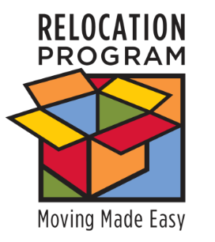
UNIT FLYER

Sponsor Training Available!
http://apps.militaryonesource.mil/esat

Having trouble helping your sponsors perform their job?

We can help!
Get your sponsors ready for the mission at hand with the new sponsorship training.

eSponsorship Application & Training - eSAT:
http://apps.militaryonesource.mil/esat
The online application provides:
- Registration
- Training
- Certificate for your files
- Sponsorship duty checklist
- Newcomer and family needs assessment
- Congratulations and welcome letter templates and packages
- Links to important Department of Defense and service moving websites
- Reporting module
- Customer satisfaction surveys
Contact: INSERT YOUR CONTACT INFORMATION

SPONSOR FLYER

So, now you’re a sponsor?
http://apps.militaryonesource.mil/esat

Don’t have a clue where to start?

We can help!
Everything you need to get ready to be sponsor is available through the new sponsorship training.
eSponsorship Application & Training - eSAT:
http://apps.militaryonesource.mil/esat
The online application provides:
- Registration
- Training
- Certificate for your files
- Sponsorship duty checklist
- Newcomer and family needs assessment
- Congratulations and welcome letter templates and packages
- Links to important Department of Defense and service moving websites
- Reporting module
- Customer satisfaction surveys
Contact: INSERT YOUR CONTACT INFORMATION

